The Stripe account must be managed by a committee member unless they have given approval for an Activator to manage this.

The person who is an administrator and/or owner on the account will need to provide personal ID and also upload bank statements /other club documentation, so unless you are comfortable to do this, please do not proceed with the verification procedure below.

You can liaise with the committee members to work through the process and transfer the ownership of the account to the Chairman/Treasurer/Secretary or other person chosen by the committee if you are not a committee member.

**You must not start setting up a new Stripe account because you are unable to verify the existing one**. The old account has your club bank account attached to it, so needs to be accessed as it has confidential club information e.g bank details and date of births, on there and someone still has access to this so could lead to fraudulent activity.

|  |  |
| --- | --- |
| **Stripe Terminology** | **Club Terminology** |
| Business / Company | Club |
| Business Executive | Not needed > click continue with no executive |
| Company Director | Not needed > click continue with no executive |
| Company Representative | an individual who has significant involvement in the club and will be the “representative” for the Stripe account. For example the Club Chairperson, Secretary or Treasurer. |
| Business Owner | Those responsible for managing and directing the club - may include President, Vice President, or Treasurer etc. They do **not** need to own 25% or more of the club |

How to contact Stripe

Stripe do not have an inbound support phone number, however if you need help with verifying your account, you can submit a phone call request from the link below and a stripe support

agent will give you a call back <https://support.stripe.com/contact>. Alternatively, If you can login into the account select the ? Help icon top right hand side, support articles and contact support. You can then select email us.

How to login into Stripe

Log into your Stripe Account here: <https://dashboard.stripe.com/login>

If you have forgotten your password, click here <https://dashboard.stripe.com/reset>

Depending on the information you have already submitted, you may need to upload/email information related to the following:

1. Business Details
2. Proof of Business Document
3. Business Ownership
4. Company Director
5. Business Executive
6. Final checks
7. Transfer of Ownership of Business
8. Incorporated Business
9. Questions and answers
10. **Business Details**

* Select Settings by selecting the Cog Icon on the top right-hand side of dashboard next to the Person Icon.



* Assuming the club is Unincorporated follow instructions below otherwise if Incorporated see changes that need to be applied under section 8



* Scroll down to the Business settings section
* Select Tax details



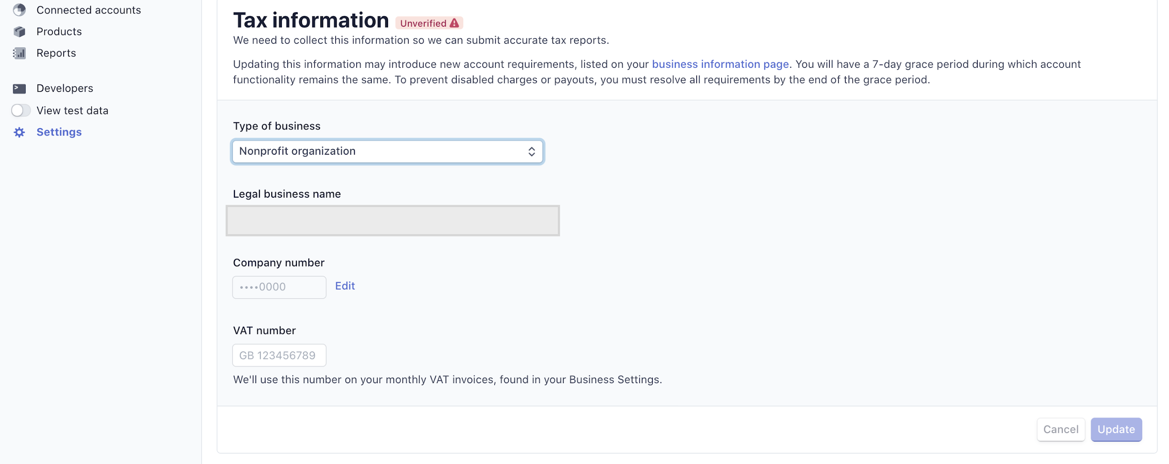

* Under Type of business, select **Nonprofit organization**
* Under Company Number/Companies House Registration Number (CRN), **input 00000000**
* Under Vat registration, input the Vat registration number if there is one
* Click Update
* **Make sure Nonprofit organization appears and the 00000000 appears before leaving this page**

1. **Proof of Business Document**

* Under Settings select the Cog Icon again
* Scroll down to the Business settings section
* Select Business Details



* Click Edit icon and **amend** the details for the name of the Cricket Club and address in the Business Details screen below **making sure the name and**

**address matches the bank statement that you will upload, even if the bank statement has the address of the committee member it will be accepted, so long as it has the Cricket Club name on there too. If it does not have the Cricket club name find a document that does e.g a Utility bill and amend to the address on this or upload the constitution making sure the club address is on there and you have amended the name and address of club under business details to this before uploading.**

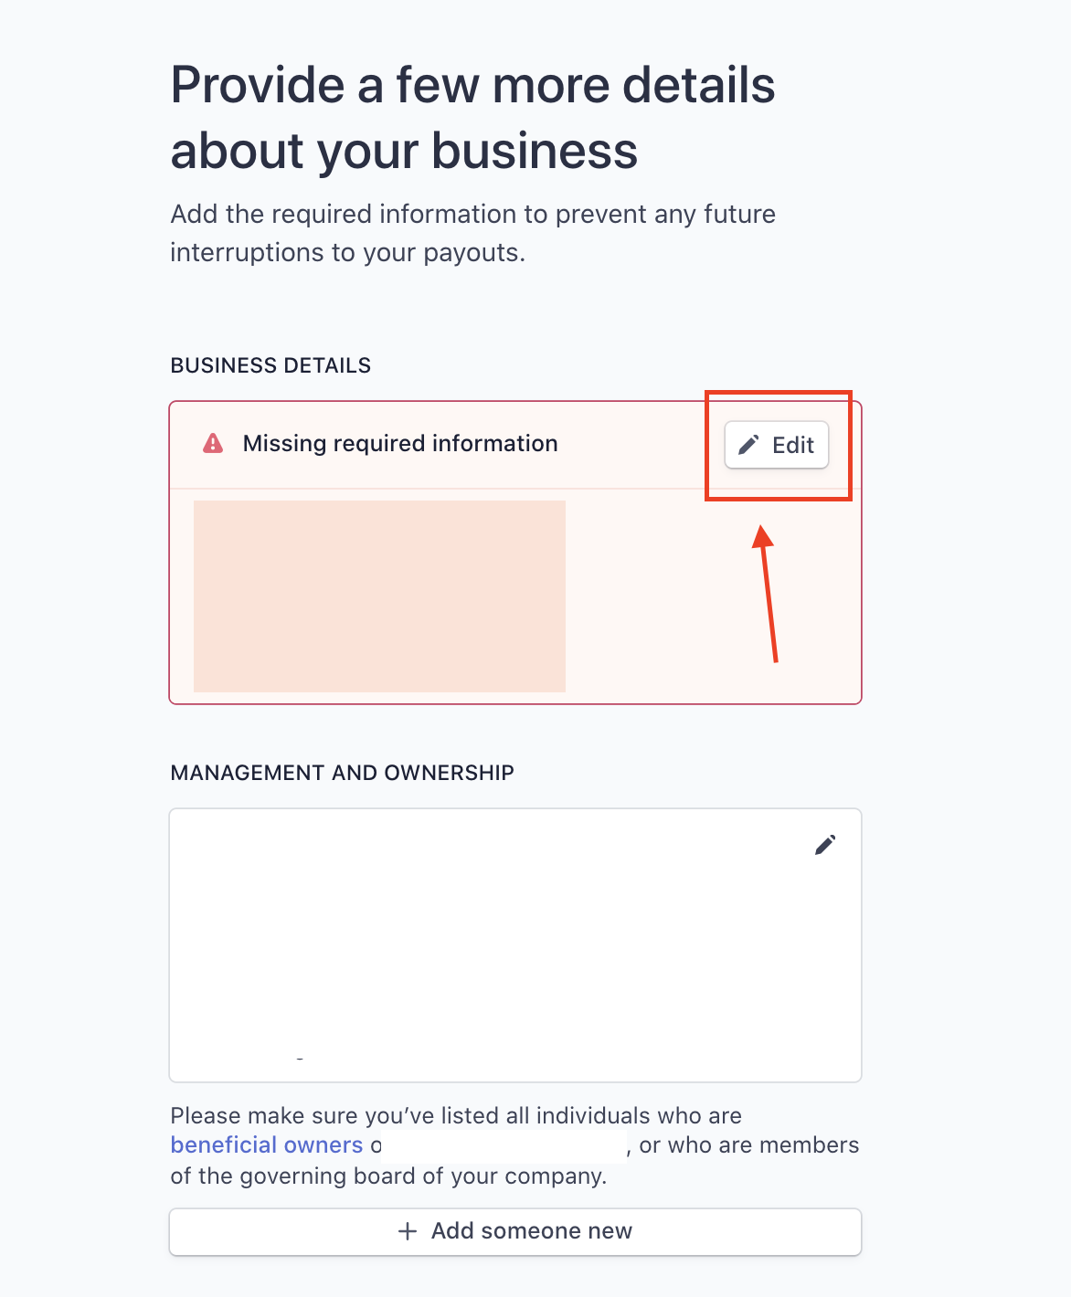

* Then click Verify now as in the screen below

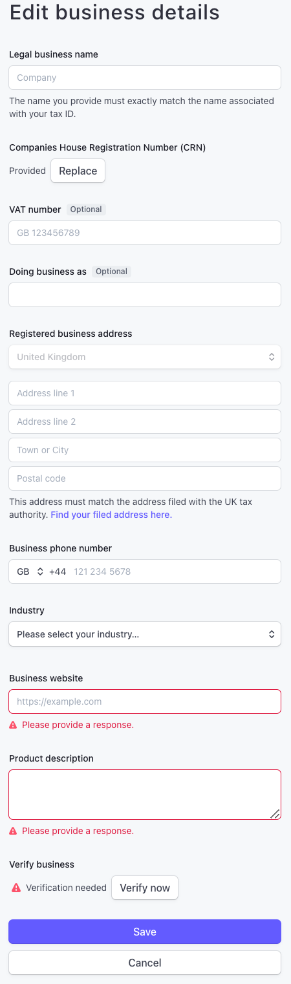

* You will now be prompted to upload a document. Click **Other** and continue to upload

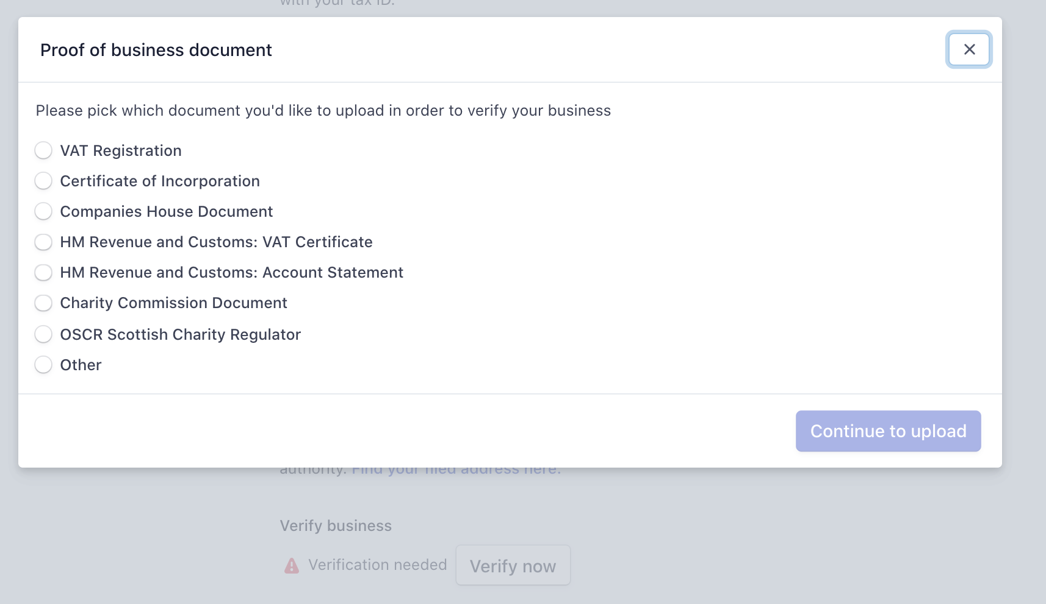

* The proof of business document can be a bank statement, utility bill, or club constitution **that matches the entity name and address entered under Business details** section as explained earlier.
* Create a PDF document or take a photo on your phone and email the actual size to yourself. Find the email and copy and save the attachment in a folder on your computer or open the photo and save in a folder from where you will be able to access it to upload.

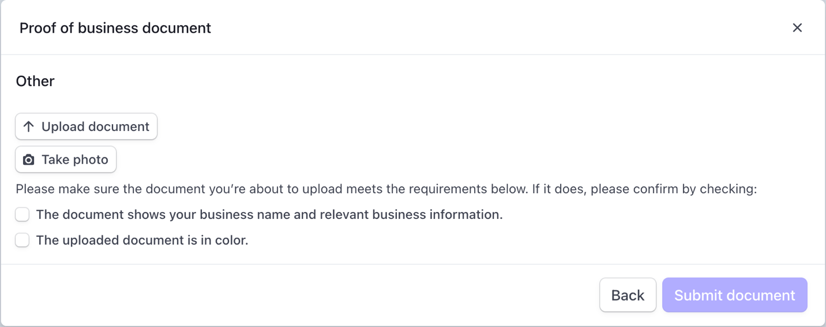

* Select Upload document to attach the document from the folder it is saved in
* Click Submit Document
* If you receive a failure error come out the screen and check if the red box has disappeared around the Business details section when you go back into Settings> Business details

1. **Business Ownership**

*Those responsible for managing and directing the club – Committee members may include President, Chairman, Secretary, Treasurer or any other Committee member. They* ***do not need*** *to own 25% or more of the club*

*If you are the company representative and not an owner so need to add a committee member, please seek their permission first as they must be prepared to upload a form of identification, this should be a government issued ID such as a passport or driver’s license.*

* Under Settings select the Cog Icon again
* Scroll down to the Business settings section
* Select Business Details



* If “Missing required information” is listed under one of the account “owners”. Please click update.

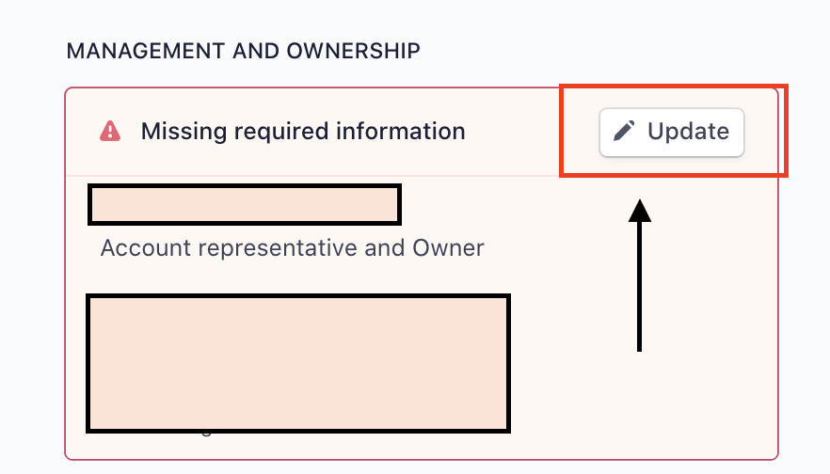

* If this box does not appear ---select the pen icon next to your name and it should take you to the upload screen
* Your ID can be a driving license showing your name and address and Date of birth, or passport showing these details that matches the name and address and Date of birth entered under Management and Ownership section for your name.
* Create a PDF document or take a photo of the front and back of your license and your phone and email the actual size of each to yourself. Find the email and copy and save the attachments in a folder on your computer or open the photos one by one and save in a folder from where you will be able to access it to upload.
* Select Update and change the details for your name, address and Date of birth to match your driving license and passport.

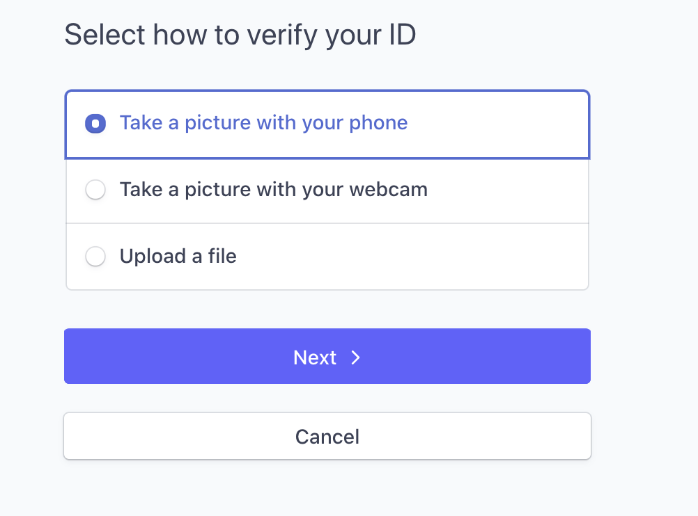

Select verify/update and upload a file. Find the file and select it. Stripe will verify the document. Repeat with the back of the driving license.

If you receive a failure error come out the screen and check if the red box has disappeared around the Management and Ownership section for you, when you go back into Settings>Business details.

Alternatively, you can choose to receive a link on your phone and enter your phone number, making sure to update the country code to GB, and then click send link. A link will be sent to your phone.   
Complete the verification via your phone.

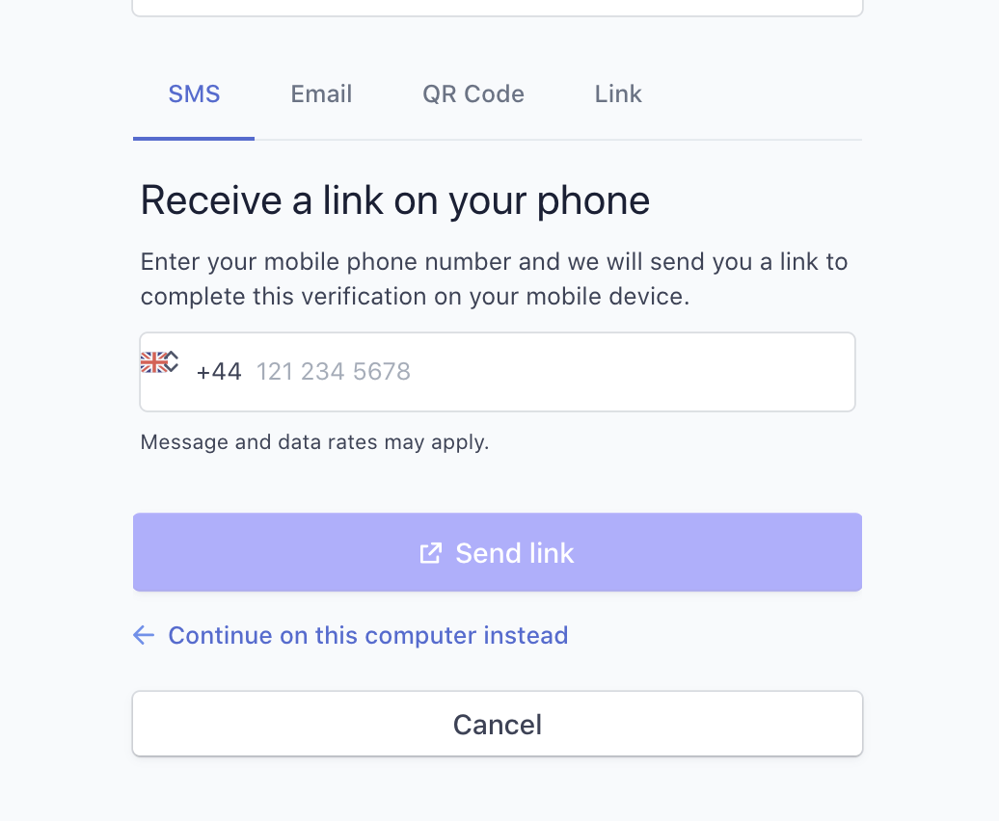

1. **Company Director**

*Missing company director information*

> Click update and then click **continue with no directors**

1. **Business Executive**

Missing business executive information

> Click update and then click **continue with no executives**

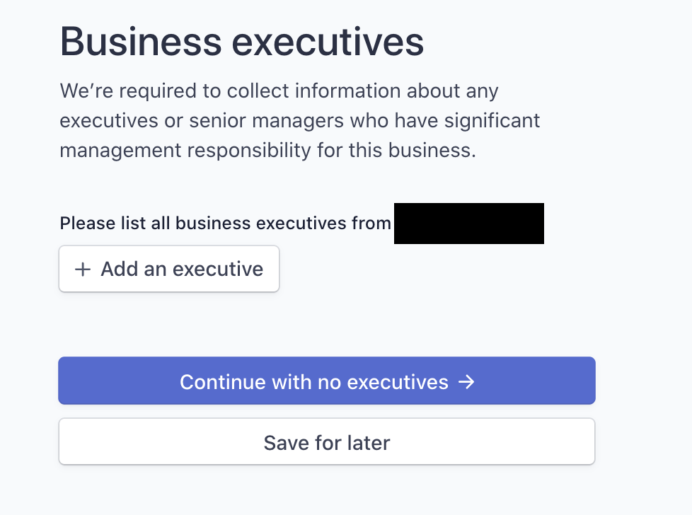

1. **Final Checks**

Select Settings > Under Business settings section select Tax Details> **make sure Business Type is still set as Nonprofit Organization and Company number shows as 00000000**

Select Settings> Under Business settings section select Business details > **make sure there are no red boxes > if they are red repeat section 3-5 until they disappear**

You should receive notification within 24 hours that the account has been verified.

**If you don’t receive this, liaise with Stripe at** [**support@stripe.com**](mailto:support@stripe.com) **to establish what else they require from yourselves to complete the verification.**

1. **Transfer of Ownership of the Business**

If the existing person can login into the Stripe account easily, they can transfer the ownership to the new person so the new person can verify the account.

The existing person who has access to the Stripe account must obtain approval from the committee members before passing the responsibility to another person. The existing person needs to log into their Stripe account – click Help – Support Articles – Contact Support – Select topic ‘Verification’ and Email Us. They must then complete the contact form.

In the contact form at this stage please email Stripe with the instructions **‘I would like to change the ownership of my account.’**

Stripe will then reply to the exiting persons email inbox and that person can then reply back to the email to Stripe, copying in the new person and committee member who has approved the transfer, then Stripe will provide the assistance to transfer the account. Please also ensure the email under Settings>account settings is changed to the new person too.

Alternatively you can do this yourself, once you have approval from the committee member:

First add the person under Settings>Team and Security section select Team>select + New member>enter email and select role as Administrator and update.

They will receive a link and can create their user password and login into the account using the email as the username.

Once they are logged in they can upload their ID when requested to do so by Stripe. Take a photo of your driving license front and back beforehand and save it to a folder from where you can select this easily.

Under Settings Cog Icon> Business settings section choose Business details >Management and Ownership select your name>edit and it should allow you to upload your ID here.

To transfer the ownership go to Settings> under Teams section >scroll to the person’s name>select the 3 dots ... and then Edit >select transfer ownership>update.

They should appear under Management and owners under Settings>Business details. They will need to upload their ID eventually under the Settings>Business details if they have not already done so and will receive an email from Stripe to remind them to do so. Please also ensure the email under Settings>account settings is changed to the new person too.

If the existing person is unable to login/uncomfortable to login as they may have to provide personal ID / no longer available as they have left the organisation or passed

away, then it is best to transfer the ownership of the account by completing the letter below.

You will need to complete the letter on club letterheaded paper and have another committee member print and **approve and sign** the transfer letter, creating a **pdf** document. **Please make sure it is in this exact format and no details are missing as they will request it again.**

Please also copy the other committee member who has approved the transfer on the email and send to [allstarscricket@ecb.co.uk](mailto:allstarscricket@ecb.co.uk) who can support you.

You will need the following information for your letter:

* Name and date of birth of previous owner
* Name and date of birth of current owner
* Stripe account number

Often the name and date of birth can be found in the ClubSpark

If you cannot obtain this information, please email [allstarscricket@ecb.co.uk](mailto:allstarscricket@ecb.co.uk)

and we will attempt to support you with finding the information-please note **information will only be supplied if a committee member is CCd on the email request**.

Your logo here

**(INSERT FULL BUSINESS ADDRESS)**

**(INSERT DATE)**

To whom it may concern,

We would like to transfer ownership of (**INSERT BUSINESS NAME**) Stripe account from:

current owner (Name of the old company representative + **Date of Birth**) to

new owner (Name of the new company representative + **Date of Birth**).

Required Business info:

**INSERT BUSINESS NAME**

**INSERT BUSINESS ADDRESS**

**INSERT ACCOUNT NUMBER**

EIN – enter N/A unincorporated non-profit organization

VAT- enter the number if you have one

COMPANY Number- Assuming your club is unincorporated log unincorporated non- profit organization company number 00000000

(Signature of the approver here)

(FULL NAME OF THE APPROVER and JOB TITLE)

**needs to be the signature of person who is a committee member approving the transfer and cannot be the same person who is taking ownership of the Stripe account, preferably the Chairman.**

The club can use the draft format below for your email to Stripe.

Hi Stripe support,

We are an **unincorporated non-profit organization** and have been asked by England and Wales Cricket Board Ltd to whom our club Stripe account is connected to ask you to help us to transfer the ownership of the club’s Stripe account to (Name of Person) from the existing administrator, who is no longer available to help.

The email of the administrator is [abcd@gmail.com](mailto:abcd@gmail.com) and our account number is acct_19xxxxxxxxxxxxx (***see notes below)

Our company number for the Tax details will be 00000000

Please find attached the completed letter and our **committee member** (Name of Person) has approved this transfer and is copied in on this email.

We need to arrange the transfer asap as our programs are restarting next week and the club also needs to verify the business as an unincorporated non-profit organization, so that our payments can be re-enabled.

Thanks

**(INSERT YOUR NAME)**

***If the club can login, your account number can be found under person icon>profile>scroll down to account number starting acct. Your email is also on the same profile.

If you are unable to login contact ECB at [allstarscricket@ecb.co.uk](mailto:allstarscricket@ecb.co.uk) copy in the committee member approving the transfer and mention you need to transfer the ownership and what your role at the club is so that you can be verified before the account number and current administrator email is provided.

1. **Incorporated Business**

Follow the instructions above and for section 1

* Under Type of business, select Limited Company
* Under Company Number, enter your Company registration number
* Under Vat registration, input the Vat registration number if there is one
* Click Update

For section 2 upload any of the documents mentioned

For section 3 business owners continue with none

For section 4 and 5 add a director and/or executive obtaining their permission first as they will need to upload personal ID documents

For section 6 make sure Settings> Tax details are set as for section 1 above and no red boxes under Settings>Business details

For section 7 should you need to transfer the ownership amend your letter for the incorporated type of business.

1. **Questions and answers**

**How will we know the verification is complete?**

If you have provided a certain amount of information Stripe may partially enable the account subject to providing the remaining information. They gather the information

over a period of time and will send email messages to the owner and administrator requesting outstanding information plus provide a deadline for sending it.

Please check your Stripe account and make sure no messages are appearing on the main dashboard when you login or under Settings>Tax Details> or under Settings> Business details.

If messages are appearing you must action them straight away, so your account is not restricted for payments.

**Where do I login?**

The Stripe website <https://dashboard.stripe.com/login>

**What if I cannot login into the Stripe account as I have forgotten my password?**

Firstly, please **never** share your login, Stripe use technology to identify this and could potentially mark the account as fraud and put on high risk. Your login details are for you to use for your personal setup on the account and you are verified as the person

accessing the account. The account can be closed if Stripe feel the club is not following their guidelines about logins and passwords.

If you are not comfortable to provide your ID for Stripe to verify you then transfer the ownership to a committee member as per section 7.

If you are comfortable to login and not a committee member, please make a committee member aware of the fact that you have access to the Stripe account if they don’t already know.

First try to reset your password, please click on the following link <https://dashboard.stripe.com/reset>

You may be asked to either upload your ID or answer 3 questions about the account to verify you.



If you choose upload ID, have this ready by taking a photo on your phone of the front and back of your driving license and emailing the actual size to yourself. Open the email

and photo and save the photos to a folder that is easily accessible. You can then select upload ID and select the ID and submit then for the other photo do the same.

If a message says your verification has been rejected, please go to  [https://support.stripe.com/contact](https://protect-eu.mimecast.com/s/CEohCNxzvsNqJmZCmkO-L?domain=support.stripe.com) for support. You can click on ‘Contact Support’, select a topic and ‘Email us’.

Send the message to establish if they have received the ID and ask them to log you in.

Please only email [**allstarscricket@ecb.co.uk**](mailto:allstarscricket@ecb.co.uk)if you still cannot get in and we will try where possible to help you. You must cc a committee member into any request if you are not a committee member.

**What if my email has changed and you cannot access the old email?**

If your email has changed so you have attempted to login and the email has gone to the old email address, please go to  [https://support.stripe.com/contact](https://protect-eu.mimecast.com/s/CEohCNxzvsNqJmZCmkO-L?domain=support.stripe.com) for support. You can click on ‘Contact Support’, select a topic and ‘Email us’.

Hi Stripe,

Hope you are well.

Please can you help me to log back into our Stripe account for our cricket club (insert Name of cricket Club) which is connected to England and Wales Cricket Board Ltd.

I no longer have access to this old email (enter old mail) and would like your help to change it to his existing email (enter new email)

Our account number is acct_*********HNrLroM (enter account number)

I need access asap as I need to verify the business so that the payments can be re-enabled as our programmes start next week.

Thanks

Your name

**Should we close the account and create a new one?**

You should attempt to access your existing account first as it has your club’s financial transaction history and also club information e.g the bank account details attached and someone has access to this so could lead to fraudulent activity.

If it was setup before Sept17 you are not charged Stripe fees on refunds, any account setup after this date means you will receive a charge on refunds of 1.5%+20p of the amount you charged the customer if this is £40 = 80p

Your existing account may show monies owed to you or monies owed to Stripe.

In addition, we will need to ask our IT consultants to detach the old account to add the new one which may take some time.

If after following the process document you have had no luck with logging into the account or transferring the ownership via Stripe, email [Allstarscricket@ecb.co.uk](mailto:Allstarscricket@ecb.co.uk) , include a committee member on the email and we will email Stripe to see what the issue is and follow this through.

If at this stage they still will not allow access to the account, we will suggest setting up a new account and asking Stripe to close the old account. We do not want old accounts left open as they may have balances of money owed to the club or owed to Stripe for refunds so we need to check the accounts and someone has access to the account and your bank details so we need to close them.

**What if I need to change the bank account?**

Contact Stripe by selecting the ? Help icon top right hand side, support articles and contact support. You can then select email us.

If you have admin role you can do this yourself via [https://dashboard.stripe.com/settings/payouts](https://protect-eu.mimecast.com/s/34I2CO7AwfALlmNSvDnPu?domain=dashboard.stripe.com).

**Where can I find my account number?**

Select the person icon on the top left-hand side of the screen> select profile>scroll to the end of the screen and your account will be here and commences acct_

**What if I still see a message saying Business Tax ID still required under Settings> Tax details?**

If you are an unincorporated organization make sure under Settings> Tax details > business type is still set as non-profit organization and under company number you have entered 00000000.

If it does not allow you to edit the company number there may be a banner on this screen, update the number to 00000000 by selecting this and entering the number.

**What if my bank statement has not been approved?**

Select Settings>Business details > **check the business details address and amend this to match the bank statement then select update and reupload the bank statement**

It can take up to 24 hours and recheck this screen to see if the message has disappeared and you have received an email form Stripe to say the verification is complete.

Normally it will say this on your dashboard that it is complete and there should be no messages.

**What if there are still red boxes under Settings> Business details screen?**

For unincorporated clubs

For Directors and executives edit and select continue with none

If you are the committee member and appear in the box Management and Ownership and this is red it may require you to add ID, so upload your ID in this box if it is red.

Your ID must match the name. If the Business ownership box does not disappear select this and continue with none for now.

If you are not the committee member under the Business ownership box add the name of a committee member with their permission who can upload their ID.

After this add this person to Settings> Team>+ New member>enter email and select role as Administrator and update. They will receive a link and can create their user password and login into the account using the email as the username. Once they are logged in they can upload their ID. You can also transfer the ownership of the account at a later stage once the programs are complete.

At this stage if a red box still appears around the Management and Ownership box, this may require the person to add ID, so upload their ID in this box under their name or

your ID by selecting edit, if it is still red. Your ID must match the name. If the Business ownership box does not disappear select this and continue with none for now.

For an incorporated limited company who has Directors.

For the Business ownership and executives box select continue with none.

If you are a Director you should appear in the box Management and Ownership and this may require you to add ID so upload your ID in this box if it is red by selecting edit. Your ID must match the name. Select continue with none for executives box for now if this box still appears.

If you are not a Director with their permission enter their name as they will need to upload personal ID eventually.

After this add this person to Settings> Team>+ New member>enter email and select role as Administrator and update. They will receive a link and can create their user

password and login into the account using the email as the username. Once they are logged in they can upload their ID. You can also transfer the ownership of the account at a later stage once the programs are complete.

At this stage if a red box still appears around the Management and Ownership box, this may require the person to add ID, so ask them to upload their ID in this box under their

name or it may require your ID so upload yours by selecting edit, if it is still red. Your ID must match the name. If the Director box does not disappear select this and continue with none for now.

For an organization that is incorporated which has Executives not Directors.

For the Business ownership and Directors box select continue with none.

If you are an Executive you should appear in the box Management and Ownership and this may require you to add ID so upload your ID in this box if it is red by selecting edit. Your ID must match the name. Select continue with none for Executive box for now.

If you are not an Executive with the committee member’s permission enter their name as they will need to upload personal ID eventually.

After this add this person to Settings> Team>+ New member>enter email and select role as Administrator and update. They will receive a link and can create their user password and login into the account using the email as the username. Once they are logged in they can upload their ID from this screen when it is requested. You can also transfer the ownership of the account at a later stage once the programs are complete.

At this stage if a red box still appears around the Management and Ownership box, this may require the person to add ID, so ask them to upload their ID in this box under their

name or it may require your ID so upload yours by selecting edit, if it is still red. Your ID must match the name. If the Executive box does not disappear select this and continue with none for now.

**Where do I upload my photo of my ID?**

Take a photo of your ID with your phone front and back making sure it is filling the camera page and easy to read and email this to your personal email. Save the jpeg attachment into a folder that you can easily access.

Select Settings>Business details > under Management and Ownership section>select edit near your name and edit this and the address so it matches your ID>then select verify and the upload screen should appear >select upload a file> next and then browse your computer and find the file and upload.

**How do we check our transactions and payments?**

You can run a report from >All transactions which will show you all transactions..> select Export >select All for the date range>select Export> the transactions will import into an excel spreadsheet at the bottom of the screen and it will show you all the amounts received as charges and refunded as refunds and adjustments and what stripe paid in as payouts in col F.

Any negative balances appearing means you owe money to Stripe and this is normally if your bank account is not set up to allow Stripe to take money from your bank account

when refunds are processed. This balance will be offset against future collections or you can offer to pay this to Stripe by selecting Balances>Add balances>add amount you intend to transfer by a bacs transfer>select Next>the bank details you need to make a payment are shown in this screen. Go and setup and make the bacs payment with the finance department then ask them to provide a copy of the bacs transfer evidence. Come back to this Balances screen>add balances> re-enter the amount>select next then select Done and email Stripe a copy of the bacs transfer making sure you add your account number and club name so they can allocate this to your account. It should appear on your All transactions report eventually.

**How do we manage disputes on the account?**

A dispute happens when a customer requests their credit card provider to refund the money they paid sometimes because they don’t know who they paid. You will receive an email and must provide evidence of why they should not be paid. If you lose the dispute you will receive a £15 charge so always check the Stripe support emails and regularly check the Stripe dashboard under Payments>Fraud and Risk>Disputes > so that you can argue against the dispute and avoid paying the £15 as you have approx 14 days to respond.

Make sure under Settings> Account details the Statement descriptor is set with your club name and include Allstars so the customer knows who collected the money and what for.

**What does the message Review your bank details-We’re unable to transfer funds between your Stripe account and your bank account?**

You need to update the bank details and readd them in under Settings>Bank accounts and scheduling> edit the bank details and update.

Stripe may require you to upload a bank statement at later stage to verify that the bank account is for the club. Upload the bank statement under Settings>Business details >edit the address to match the bank statement if it is different > and then will allow you to upload the bank statement.

**What if I have more than one Stripe account how do I make sure I am verifying the right one?**

Select the down arrow next to the name on the account on the top left-hand corner, this should show you which accounts you have under your existing email, so that you can toggle between them.

**What if you receive a message saying your Stripe account balance has fallen into negative?**

“A negative balance means your customers will not be able to get their refunds as expected. To help fix this, a debit in the amount of £10.00 will be initiated from your bank account in order to make your Stripe account balance whole again. The debit may appear in as soon as two days. You can keep an eye on the status of the debit in your dashboard, and it’ll also appear on your bank statement as “Stripe” with Service User Number 714613.”

This message is just prewarning you that as a refund has been generated so Stripe will collect the portion of money the club received to repay the customer. If your bank does not allow money to be deducted the amount will be offset against a future receipt and the net amount paid to your account.

Furthermore, if the balance remains as negative the payouts could be turned off until yourselves pay the balance to Stripe by a bacs transfer.

This can be handled by contacting Stripe, select the ? Help icon top right hand side, support articles and contact support. You can then select email us.

To pay Stripe select Balances>Add to balance >Refunds and Disputes. Enter the amount you want to pay and select>Next>this will then show you the Stripe bank account you need to pay>Select Done and this is telling Stripe that you will be making the payment.

Now proceed with your Bank to arrange the payment and obtain the proof of payment and email this to Stripe while logged into your Stripe dashboard.

To set up a support email select the ? Help icon top right hand side, support articles and contact support. You can then select email us.