HOW TO
GUIDE FOR CLUBSPARK

ClubSpark is a simple and flexible management tool for All Stars Cricket centres and coaches.

Through this tool clubs can set up a profile, add activators and administrators as well as creating and amending training sessions to name but a few features.

ECB administrators will have access to all the information contained within ClubSpark, as well as having the ability to change settings, should a club not be able to do so.

CONTENTS:

How do I register on to the ClubSpark system? Page 3
How do I log in to ClubSpark & set up my All Stars Cricket programme? Page 6
What else can I do in ClubSpark? Page 12
How do I create a new programme? Page 12
How do I view/edit our programme/session details? Page 15
How do I choose the right activator? Page 16
How do I add an Activator? Page 16
How do I add an Administrator? Page 17
How do I know if a new Activator/Administrator has been registered? Page 18
How do I update my club’s electronic register? Page 19
How do I email all the parents signed up to my club? Page 20
How do I print/export all the information on my clubs’ profile? Page 20
How do I refund a parent? Page 20
What do I do now I’m registered on to ClubSpark? Page 21
Notes for ECB administration users Page 22

How do I register on to the ClubSpark system?

Go to https://ecb.clubspark.uk/ and you will be presented with the following screen:
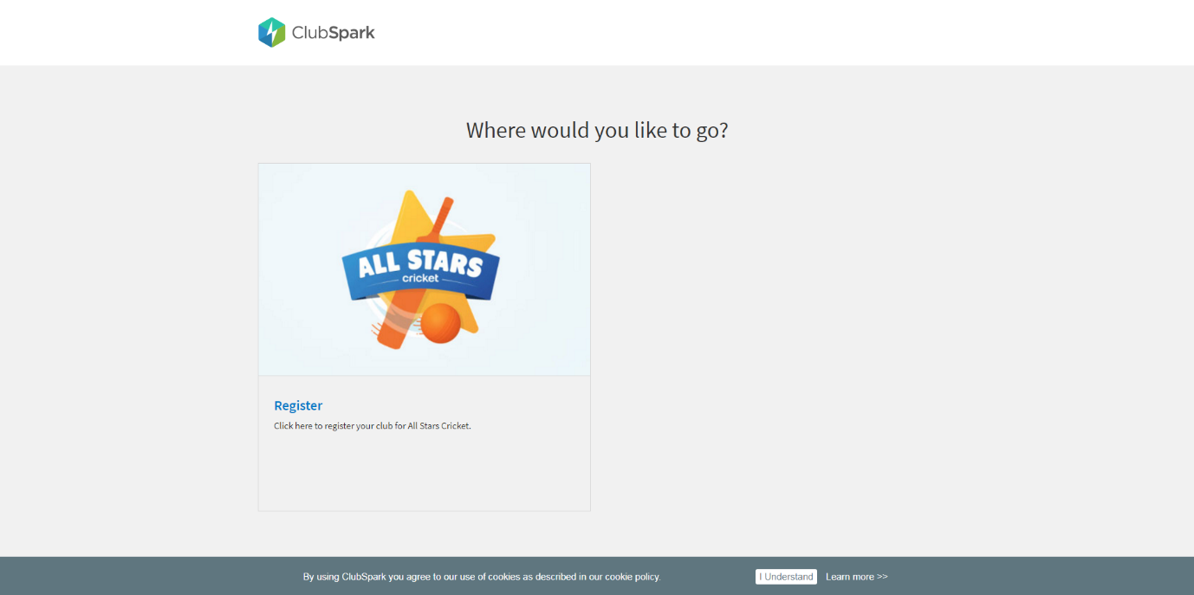
Click on the ‘Register’ button.

The following screen will then appear:
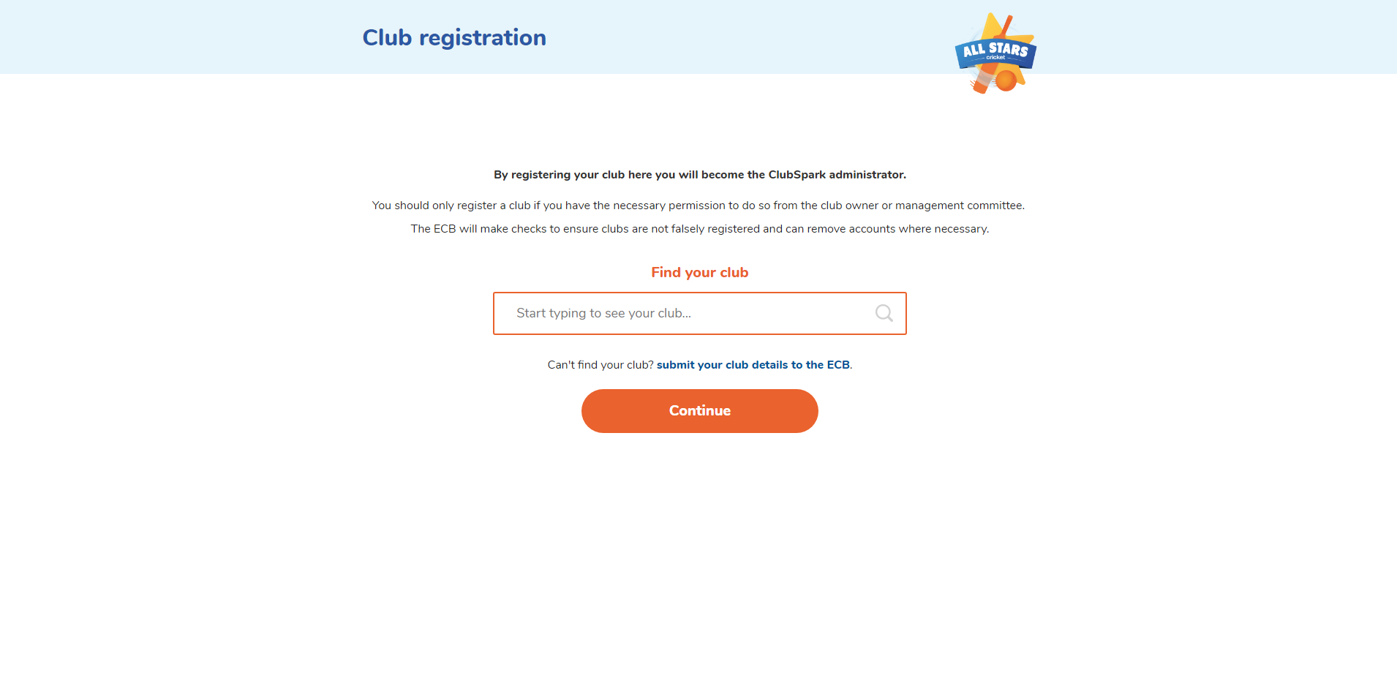

If you are an existing ECB registered club, simply enter your club’s name in the ‘Find your club’ search engine and press ‘continue’.

If you are not an ECB registered club, then please click on the blue link titled, “submit your club details to the ECB”.
You will then get taken to the following screen to input your clubs’ details:

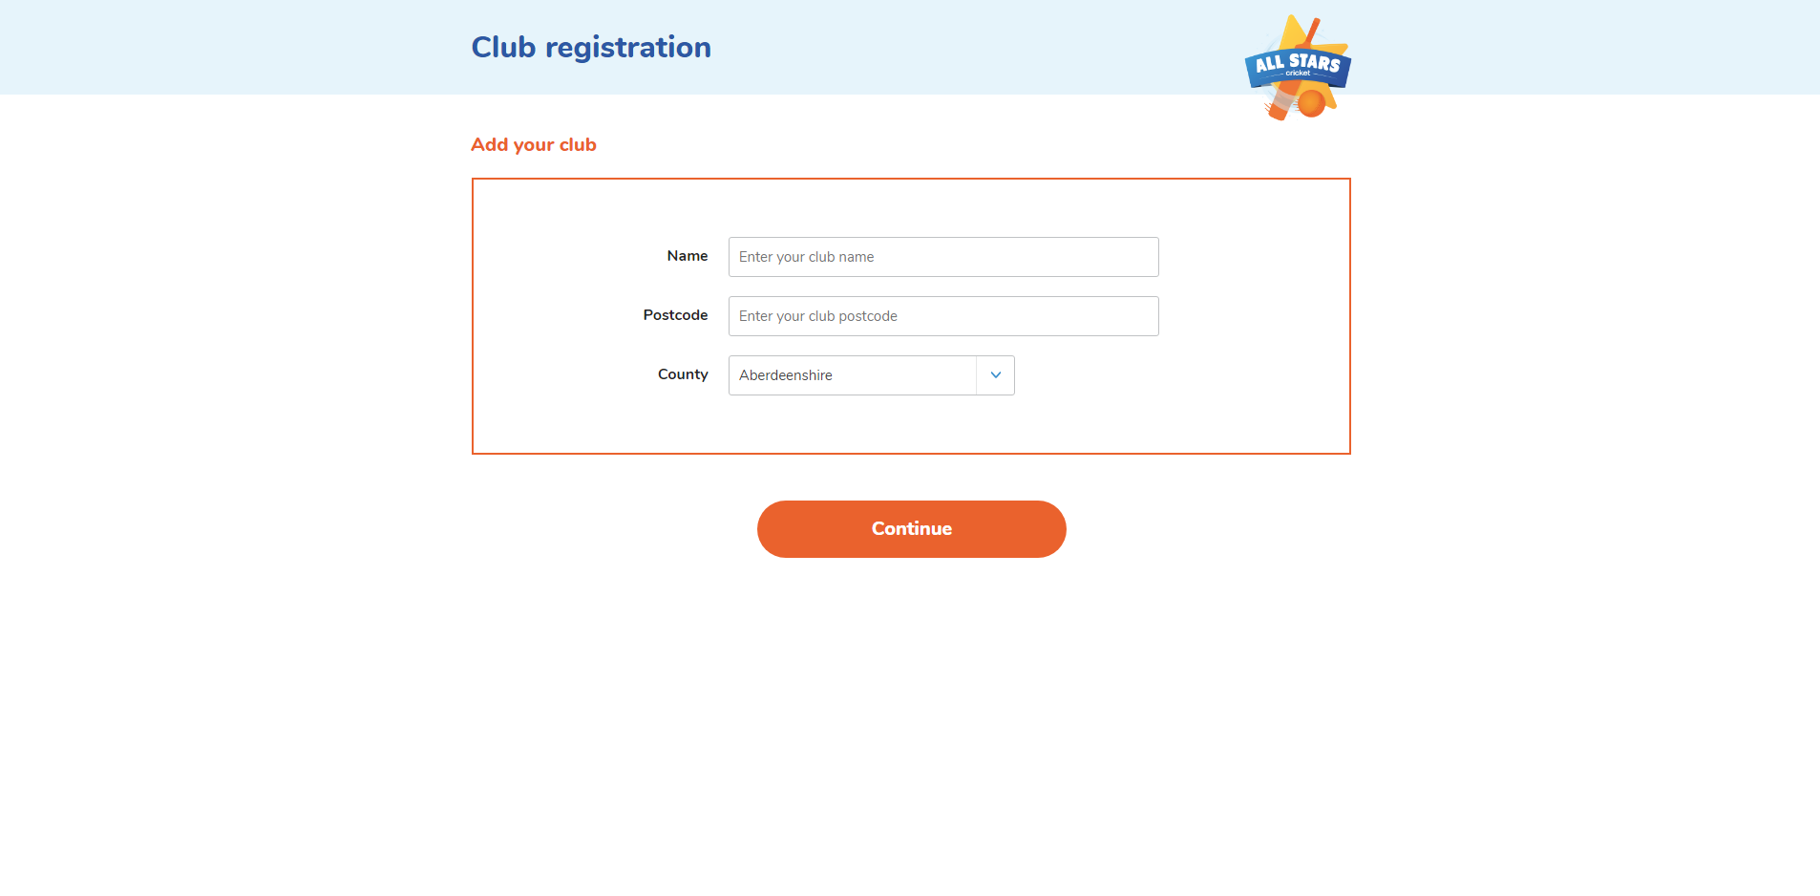

Click on ‘Continue’ to go to the following screen where you need to input your personal details:

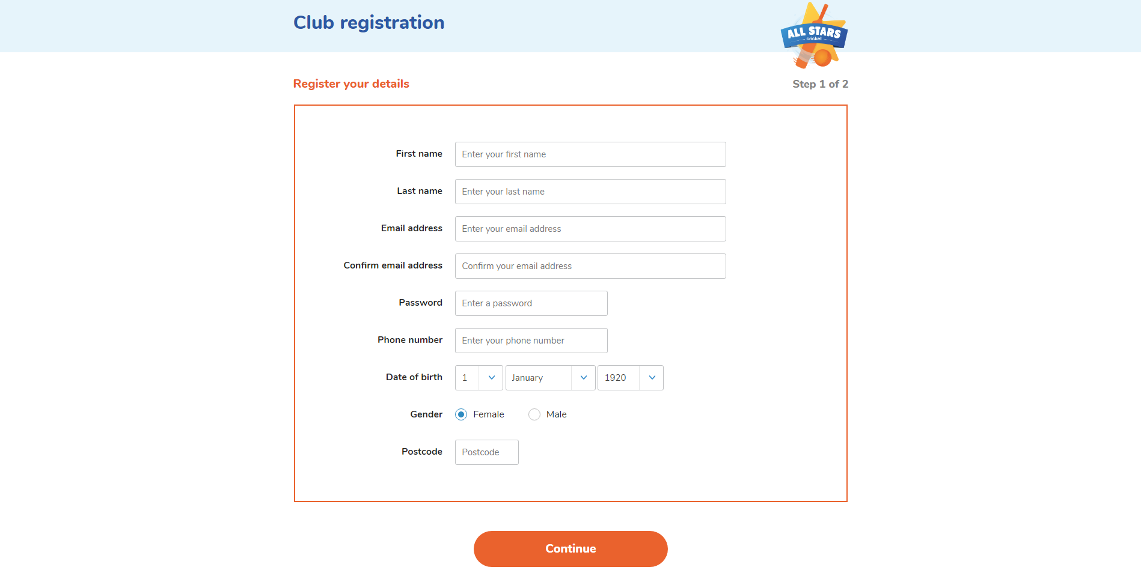

Click on ‘Continue’ to get to the next page:

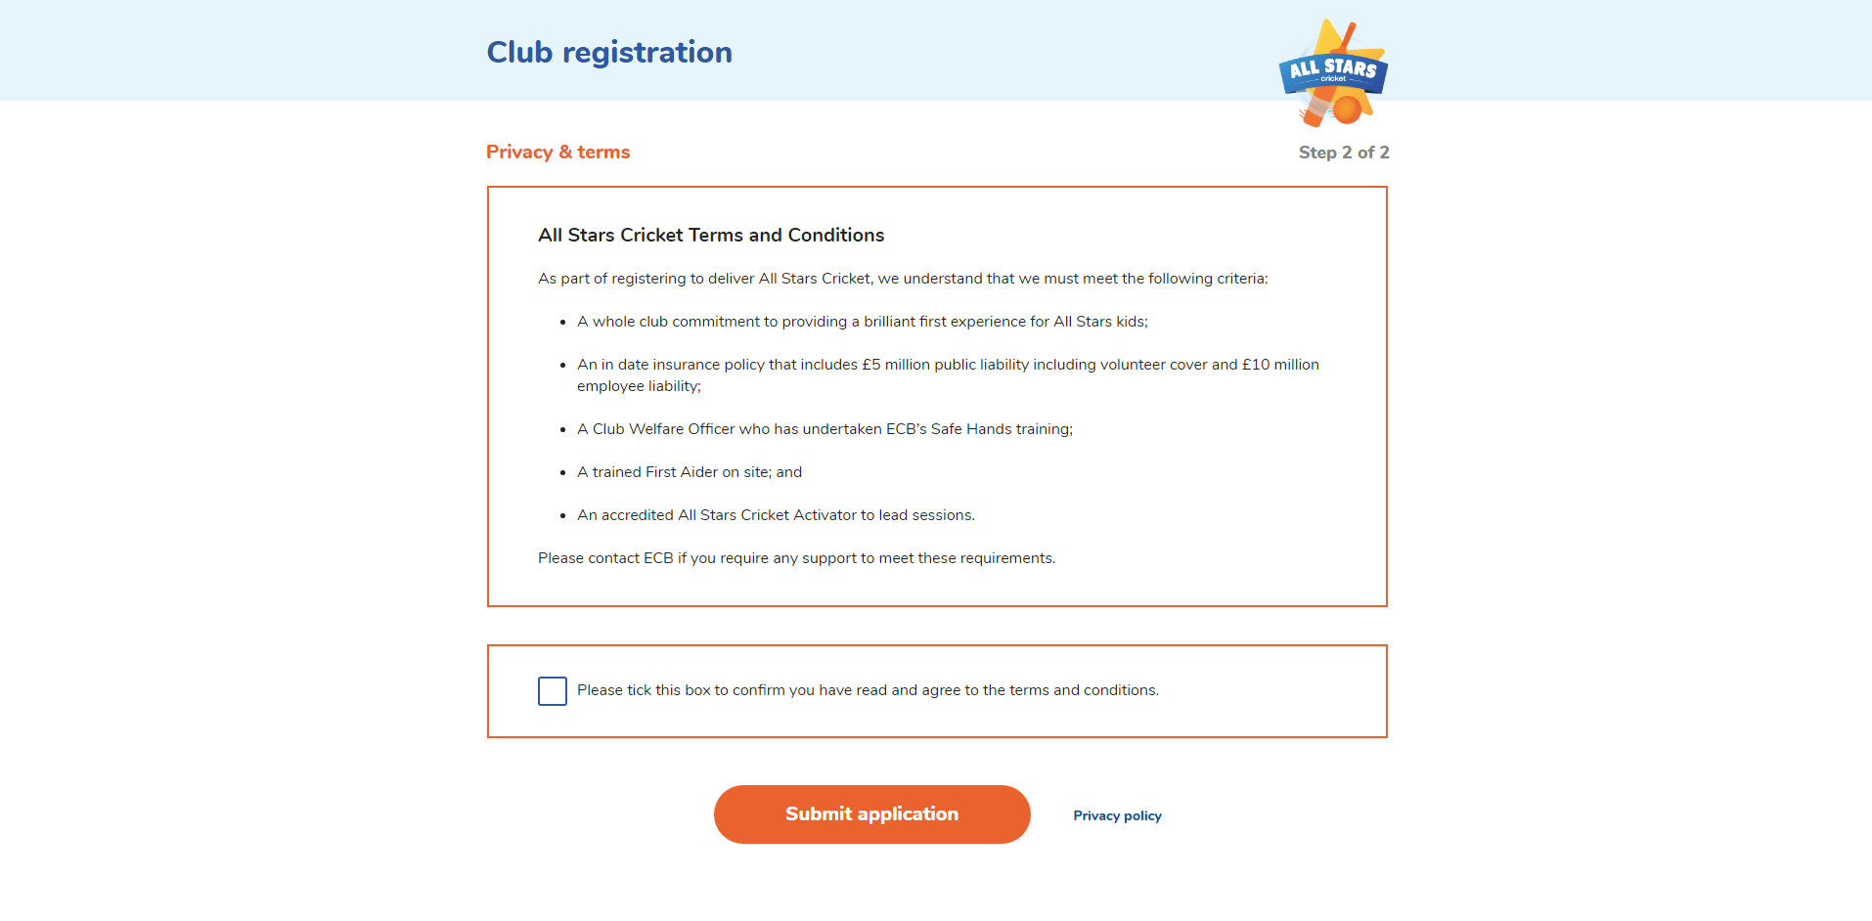

Once you have read through the terms and conditions, tick the box to confirm that you agree and then click on ‘Submit application’, which will take you to the final registration screen:

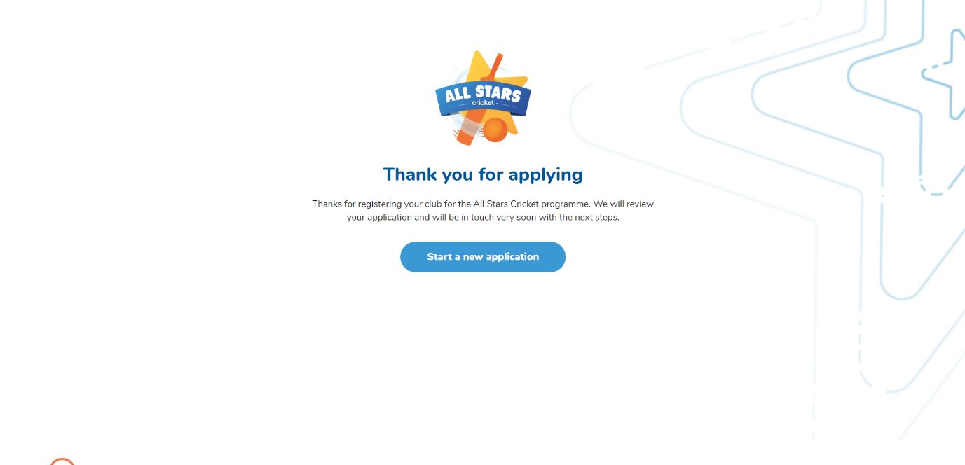

Your details will now be sent to the ECB to await authorisation.

You will be notified via email to let you know your club has been registered.

Once your club has been registered, or if your club is already registered, you will need to log in to ClubSpark, to continue setting up your clubs’ profile.

How do I log in to ClubSpark & set up my All Stars Cricket programme?

If this is the first time you are logging in to the ClubSpark system; to ensure that you have a smooth experience first-time round, we would recommend you set aside a 15-minute window of time to complete all the required fields. We would also advise you to have the following information to hand before proceeding to log in:

- Who your lead administrator and lead activator are going to be
- Your lead activators waist and chest measurements (in inches) for their kit
- A delivery address that can accept and sign for deliveries as your centre kit and uniforms will come to this address so do not choose your clubs address if your club house is closed during normal delivery hours

Once you have all this information to hand, you are ready to log in to ClubSpark.

Go to https://ecbauth.clubspark.uk/account/signin to sign-in to your ClubSpark account using your chosen login details from when you initially registered:

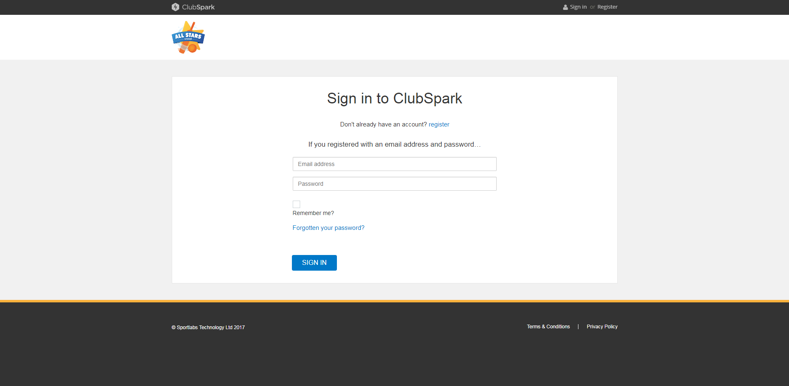

Please note that once you have input your details, you need to click on the ‘SIGN IN’ button, as opposed to pressing the Enter button as this will not allow you to log in successfully.

The first time you log in to ClubSpark, you will be presented with the following screen:

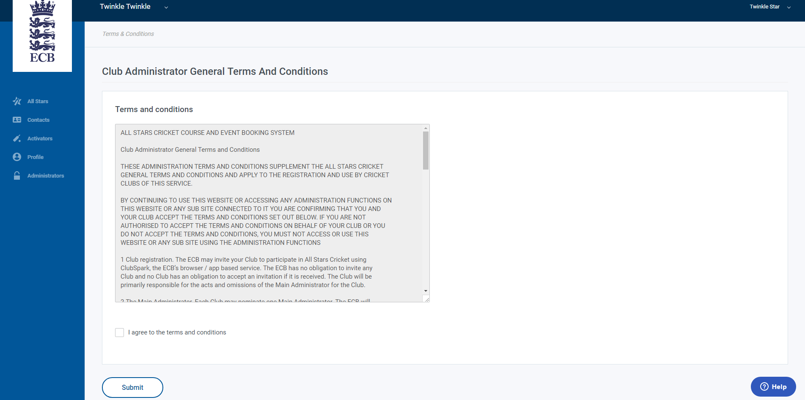

Once you have read through the terms and conditions, tick the box to confirm that you agree and then click on ‘Submit’.

The following pop up will then appear asking you to choose your activators kit size. Select the appropriate measurements and click on ‘Submit size’:

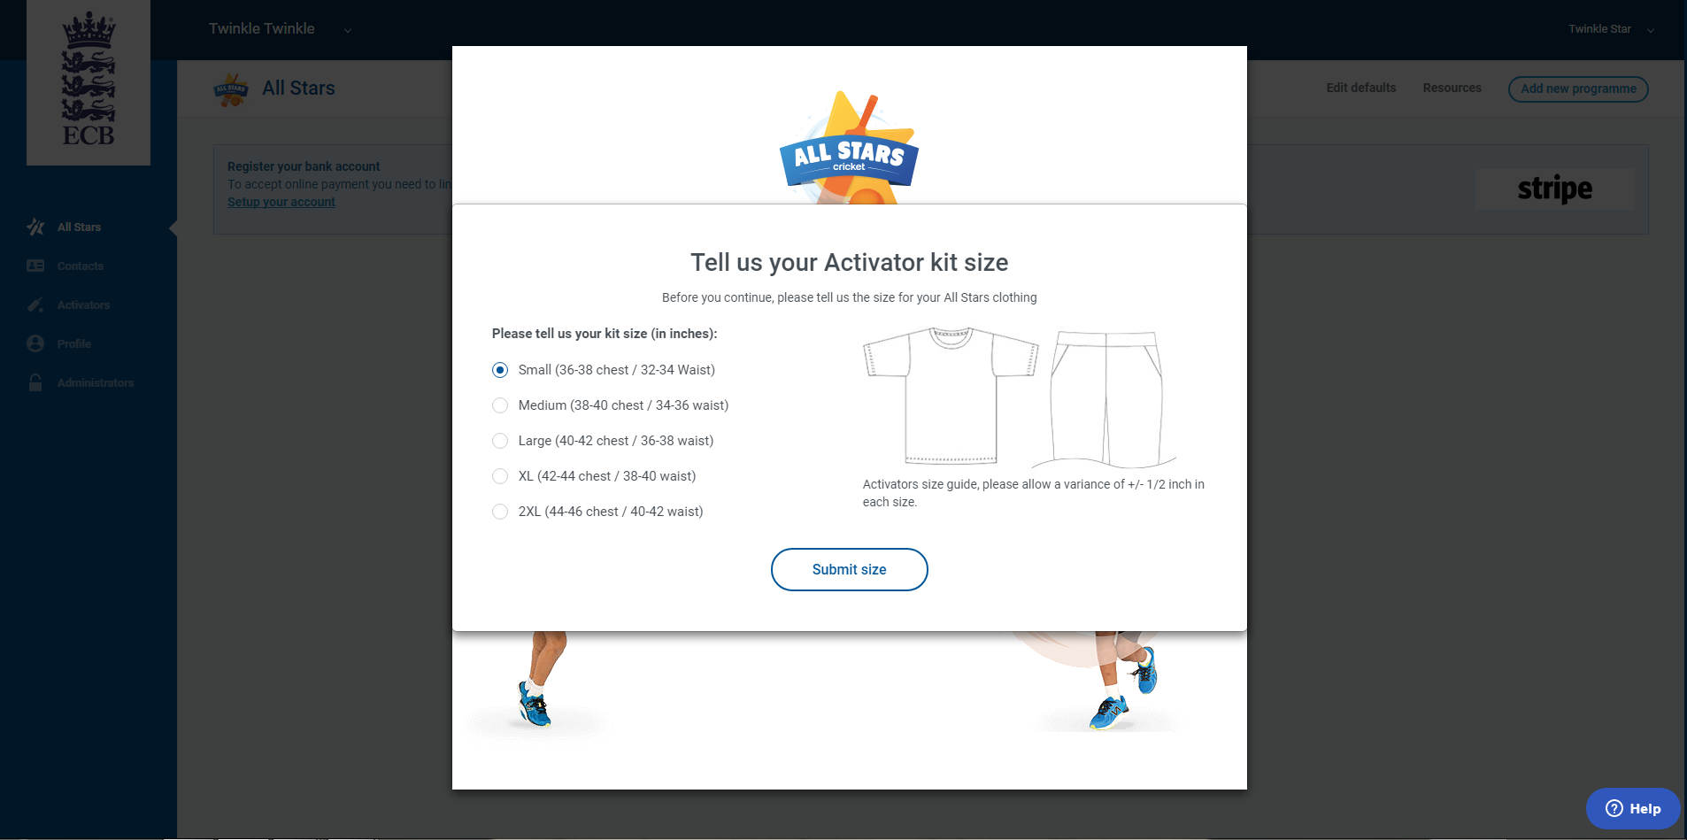

A confirmation screen will then appear, thanking you for your size submission:

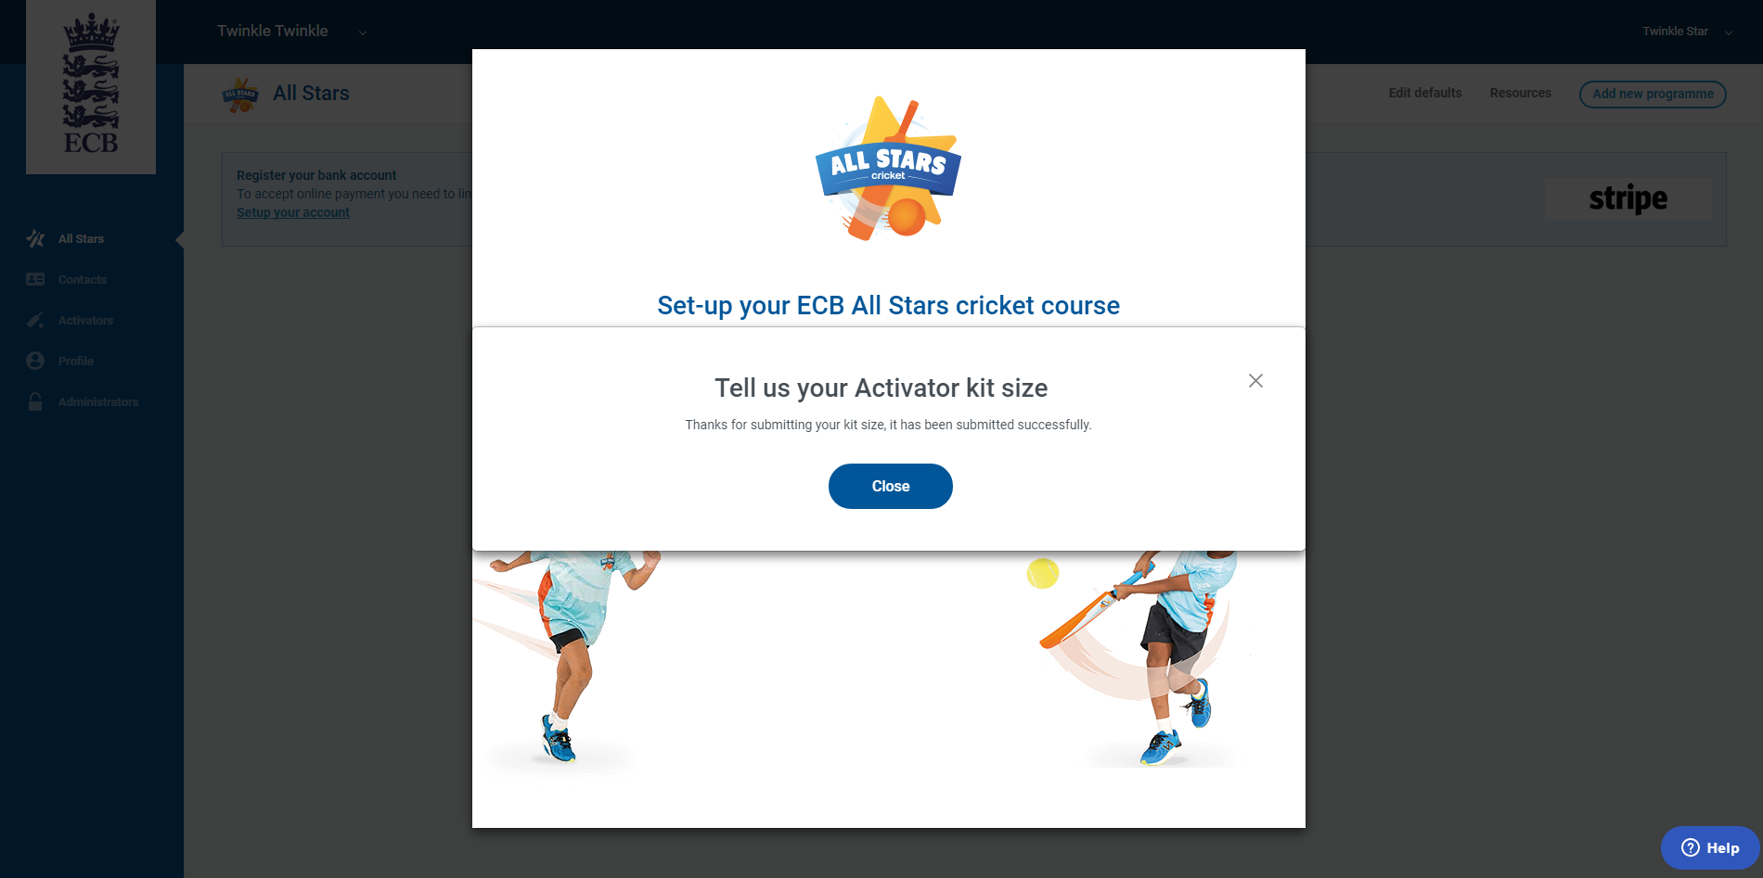

Once you click on the ‘Close’ button, another pop up will appear; prompting you to set-up your ECB All Stars cricket course.

You will now complete a step by step guide to get your club up and running with your ECB Entry Level Programme, which in this case is All Stars Cricket:

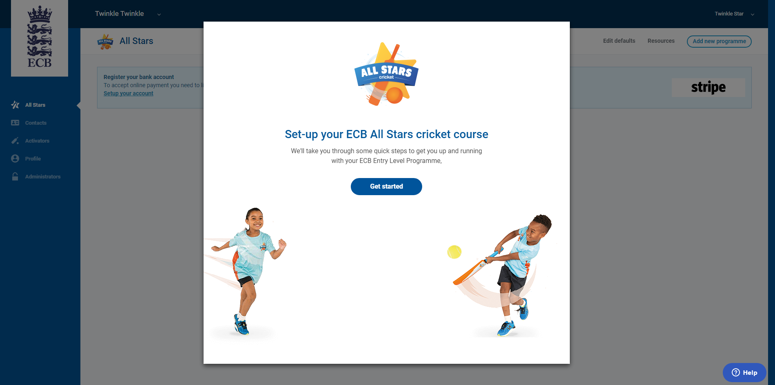

You will need to click the ‘Get started’ button and then go on to input the following information:

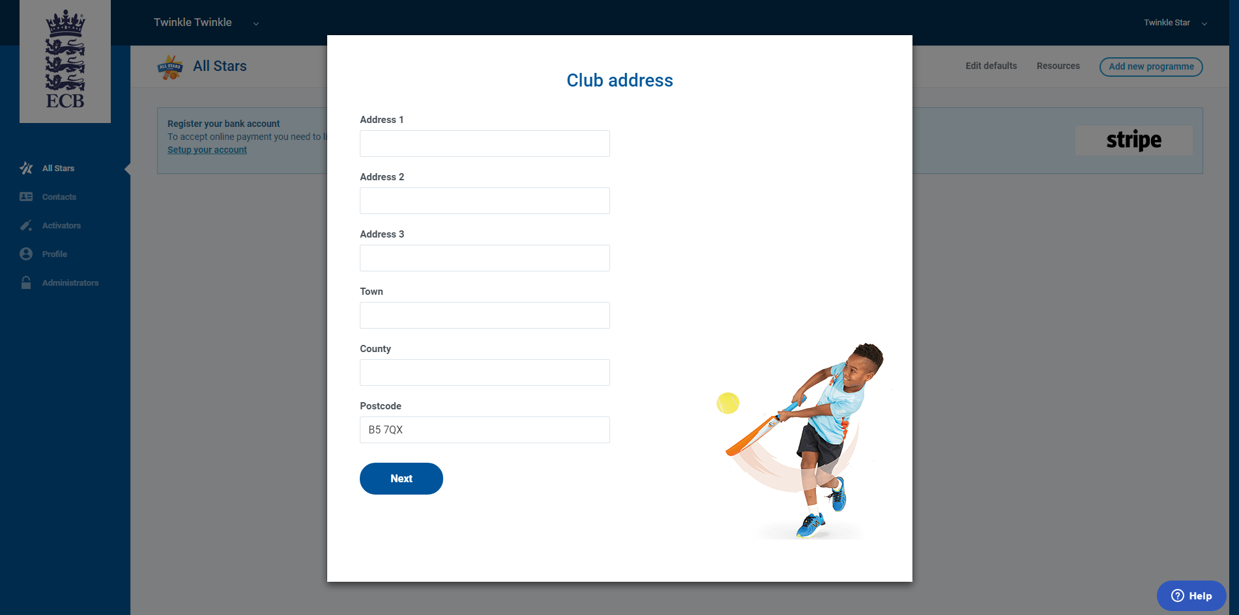

Your club’s registered address

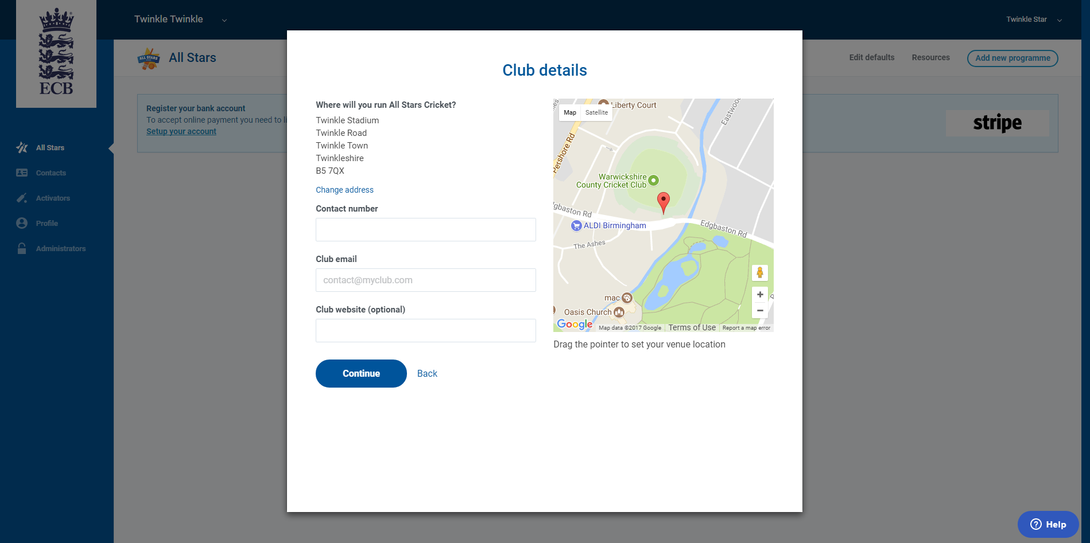

Your club’s contact details (including telephone number, email address, website address and the option to provide your club’s location on Google Maps

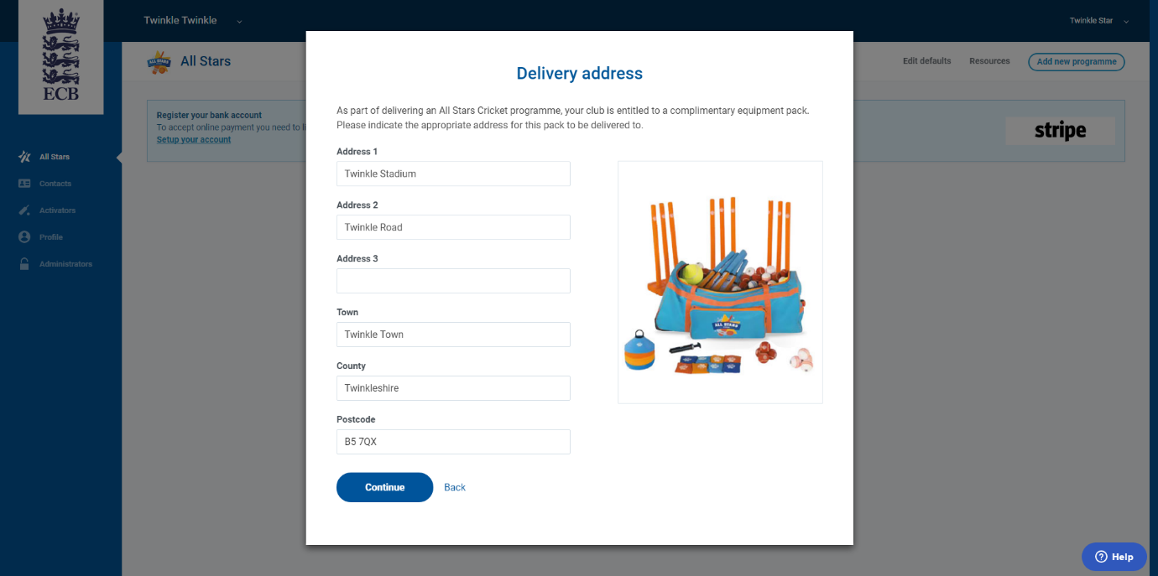

Your club’s delivery address (if your club house is closed during normal delivery hours, please input an address that can accept and sign for deliveries).

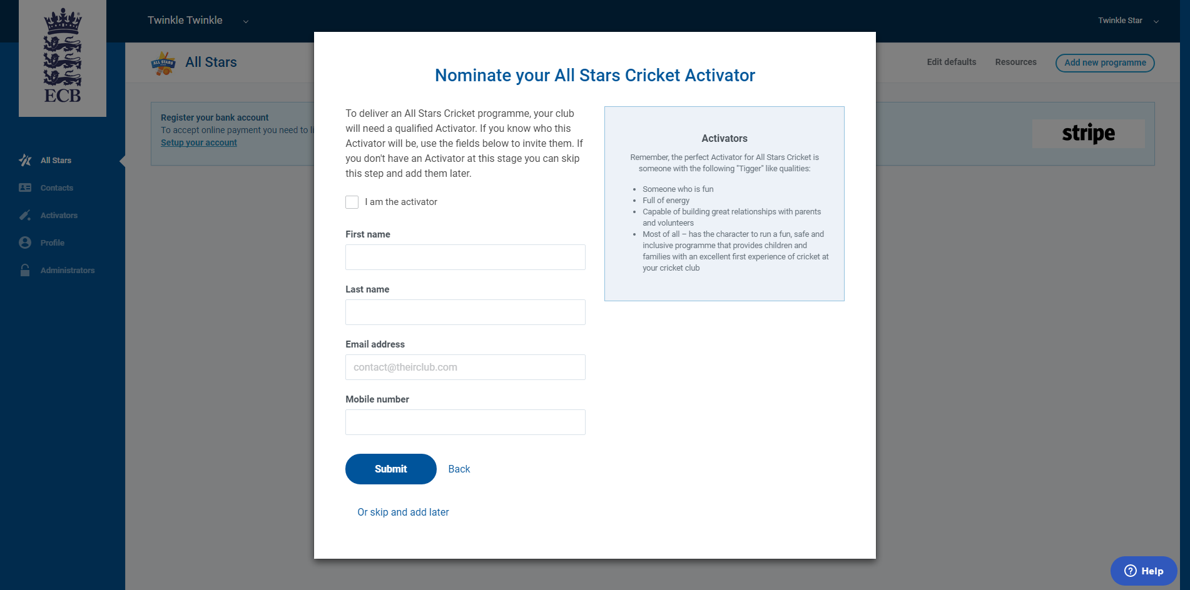

Nominating an activator*; your club’s activator can be you or you can nominate someone else by inputting their name, email address and a contact telephone number. Please note that this stage can be skipped until a later date.

(*please see instructions on ‘How do I choose the right activator?’)

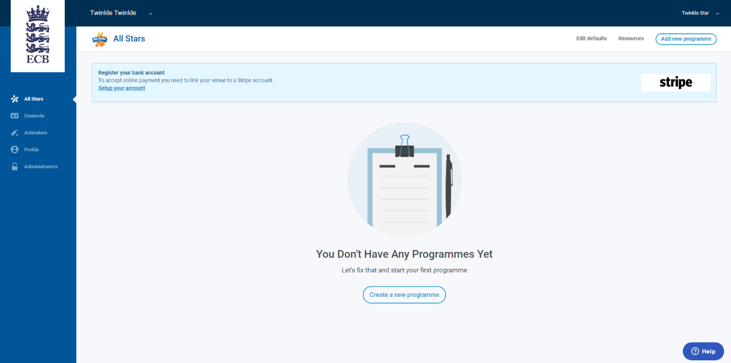

Once you have input this information, the initial set-up wizard will be complete.

You will now have the option to create a new programme and to register you club’s bank account details through our payment system; Stripe.

By registering your club’s bank account details with Stripe, allows funds to go directly in to your account when a parent registers and pays to take part in All Stars cricket.

Please note that unless you have set up a Stripe account, your programme will not show up on the public search engine:

https://www.ecb.co.uk/play/all-stars

For more details on how to use the Stripe payment system, please refer to the ‘How To Guide for Stripe.’

What else can I do in ClubSpark?

Once logged in to ClubSpark, there will be icons running down the left-hand side of the page:

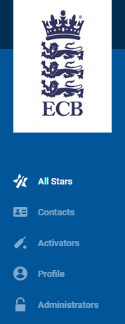

All Stars: this will allow you to access your programme information and the electronic register

Contacts: anyone who is linked to the club’s profile will have their details stored here (including parent’s and children’s information as well as club members)

Activators: shows you a detailed list of your club’s activators

Profile: contains all your club’s public information (contact details, course details etc.)

Administrators: the will show you a detailed list of your club’s administrators

How do I create a new programme?

- Details
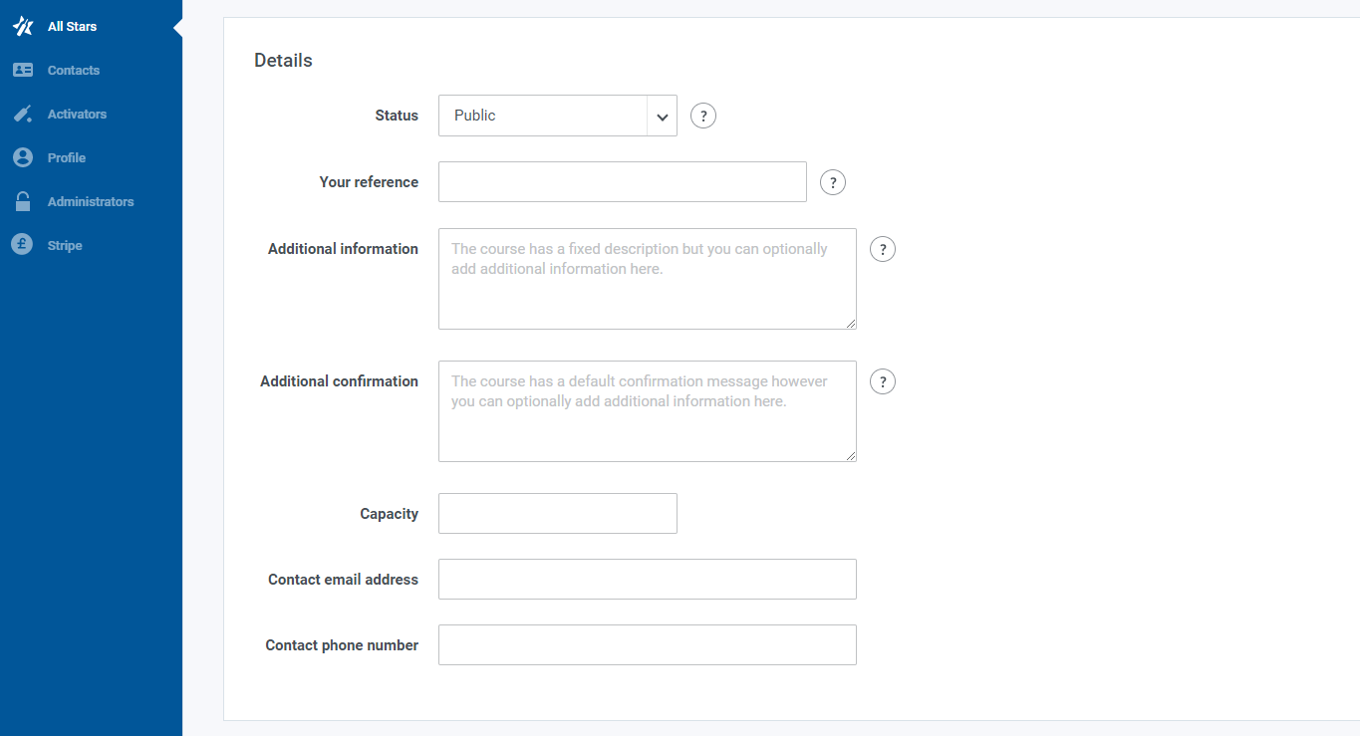

Here you can set the status of your All Stars programme to;

- Public: your course can be found on the public website and anyone can sign up
- Hidden: your course will not be visible on the public website so no one can sign up
- Direct link only: people can only sign up to your course if you send them a direct link (once you are in your ‘current programme’, the direct link will be at the bottom of the page)
- Archived: your course will be cancelled, archived and no longer available to sign up to

You are also able to do the following in this section:

- Input a reference for your club/programme
- Add additional information about your sessions e.g. if there are extra sessions past the designated 8 sessions (the course will have a fixed description but you can add additional information here)
- Add additional information to the confirmation email that gets sent out to parents once they’ve booked (the course will have a default confirmation message but again, you can add additional information here)
- Input your clubs’ best contact details (email and phone number) – please note that this is classed as public information so in an instance where a parent wishes to contact their chosen club, they may request these details so please make sure these details are suitable – usually the Lead Activator is the best point of contact but you can decide who is best

- Costs:

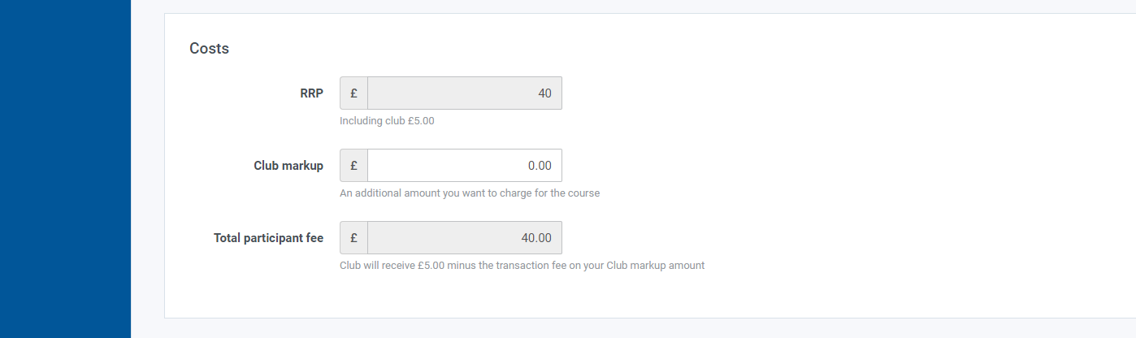

Under this section, you have the option to amend the price you will be charging as a club to take part in the All Stars Cricket sessions. The initial price of £40 can have an additional mark-up added on to cover the clubs’ costs. The total figure here will be reflected in the ‘Total participant fee’. If you use public search engine, to search for other clubs’ in and around your area, you can compare prices to see what the average is and select your own price accordingly.

- Session Defaults:

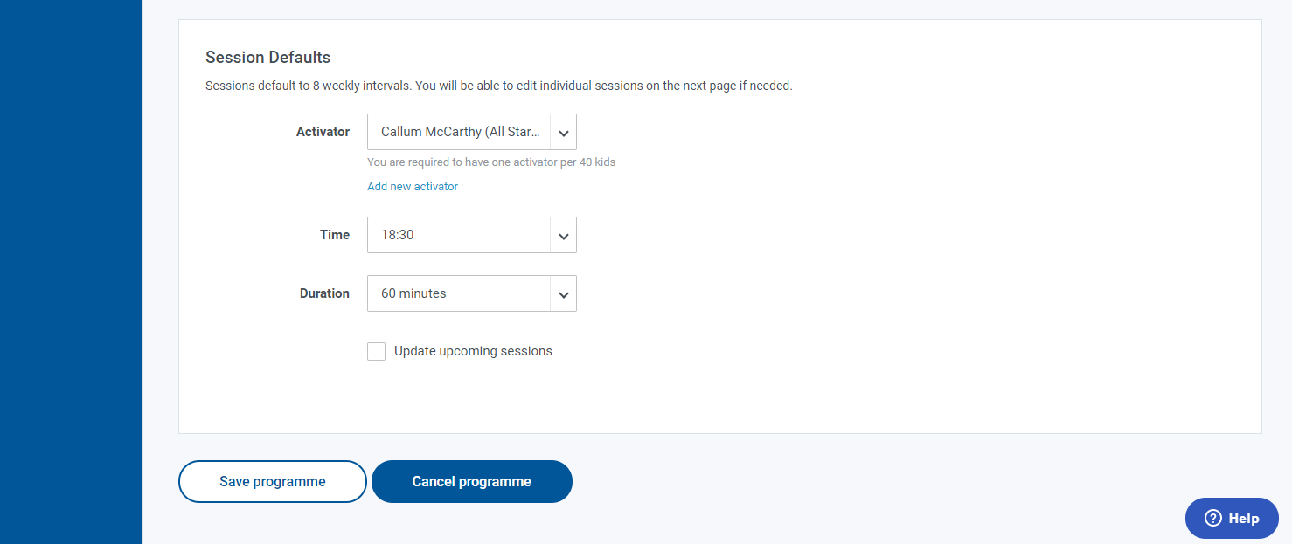

You can select the Lead Activator for your All Stars Cricket sessions, by selecting a name under the Activator drop-down. Only activators that have been manually input in to your club’s profile will show on this drop-down. Make sure you select the correct person here, as you will only receive ONE free Activators kit per 40 children, meaning any amendments later-on down the line may mean an incorrect sized kit gets despatched.

You can also change the session start time and its duration here. Pease note that if you are amending the time/duration of your session, you need to tick the box marked ‘Update upcoming sessions’, to make the change effective immediately and to make sure that all sessions are updated accordingly. Please note that this is a 24 hour clock so make sure you select the correct time.
How do I view/edit our programme/session details?

Once you are in your current/active programme, you have the option to make amendments to your programme/sessions by clicking on the corresponding links in the top right hand corner marked ‘Edit programme’ and ‘View sessions’.

To edit your programme, click on the corresponding link, or alternatively click button marked ‘Active’ next to the green dot (above your electronic register):

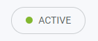

Edit programme: from here you can amend/add information to your programme, under 3 categories: Details, Costs and Session Defaults***

***Please refer to ‘How do I create a new programme?’ for further details

If you wish to change the date of an individual session (as opposed to all sessions), you will need to come out of the ‘Edit programme’ tab and go to the tab marked ‘View sessions’

View sessions: from here you can view and amend the date of your 8 individual sessions as well as amending the time and duration each session by doing the following:

Log in to ClubSpark > click the All Stars tab on the left > select the current programme > click on the button in the top right corner marked 'View Sessions' > select the session that was cancelled > amend the date/time using the calendar icon > click on ‘Save class’.

This will now reflect on your electronic register as the cancelled date being removed and an extra session being added on to the end.
You can do this as many times as needed e.g. if you experience repeatedly bad weather

How do I choose the right activator?

To deliver an All Stars Cricket programme, your club will need a qualified Activator. If you know who this Activator will be, you will simply need to invite** them by inputting their details. If you don't have an Activator at this stage, you can input your details for now and amend the club’s profile later by adding a new activator.

** please see instructions on ‘How do I know if a new Activator/Administrator has been registered?’

Remember, the perfect Activator for All Stars Cricket will possess the following qualities:

- Someone who is fun and full of energy
- Someone who is capable of building great relationships with parents and volunteers
- Someone who has the character to run a fun, safe and inclusive programme that provides children and families with an excellent first experience of cricket at your cricket club
- Someone who can commit to all the chosen session dates (remembering that if sessions are called off due to bad weather, extra sessions will need adding on to the end of the programme and someone will need to run these)

How do I add an Activator?

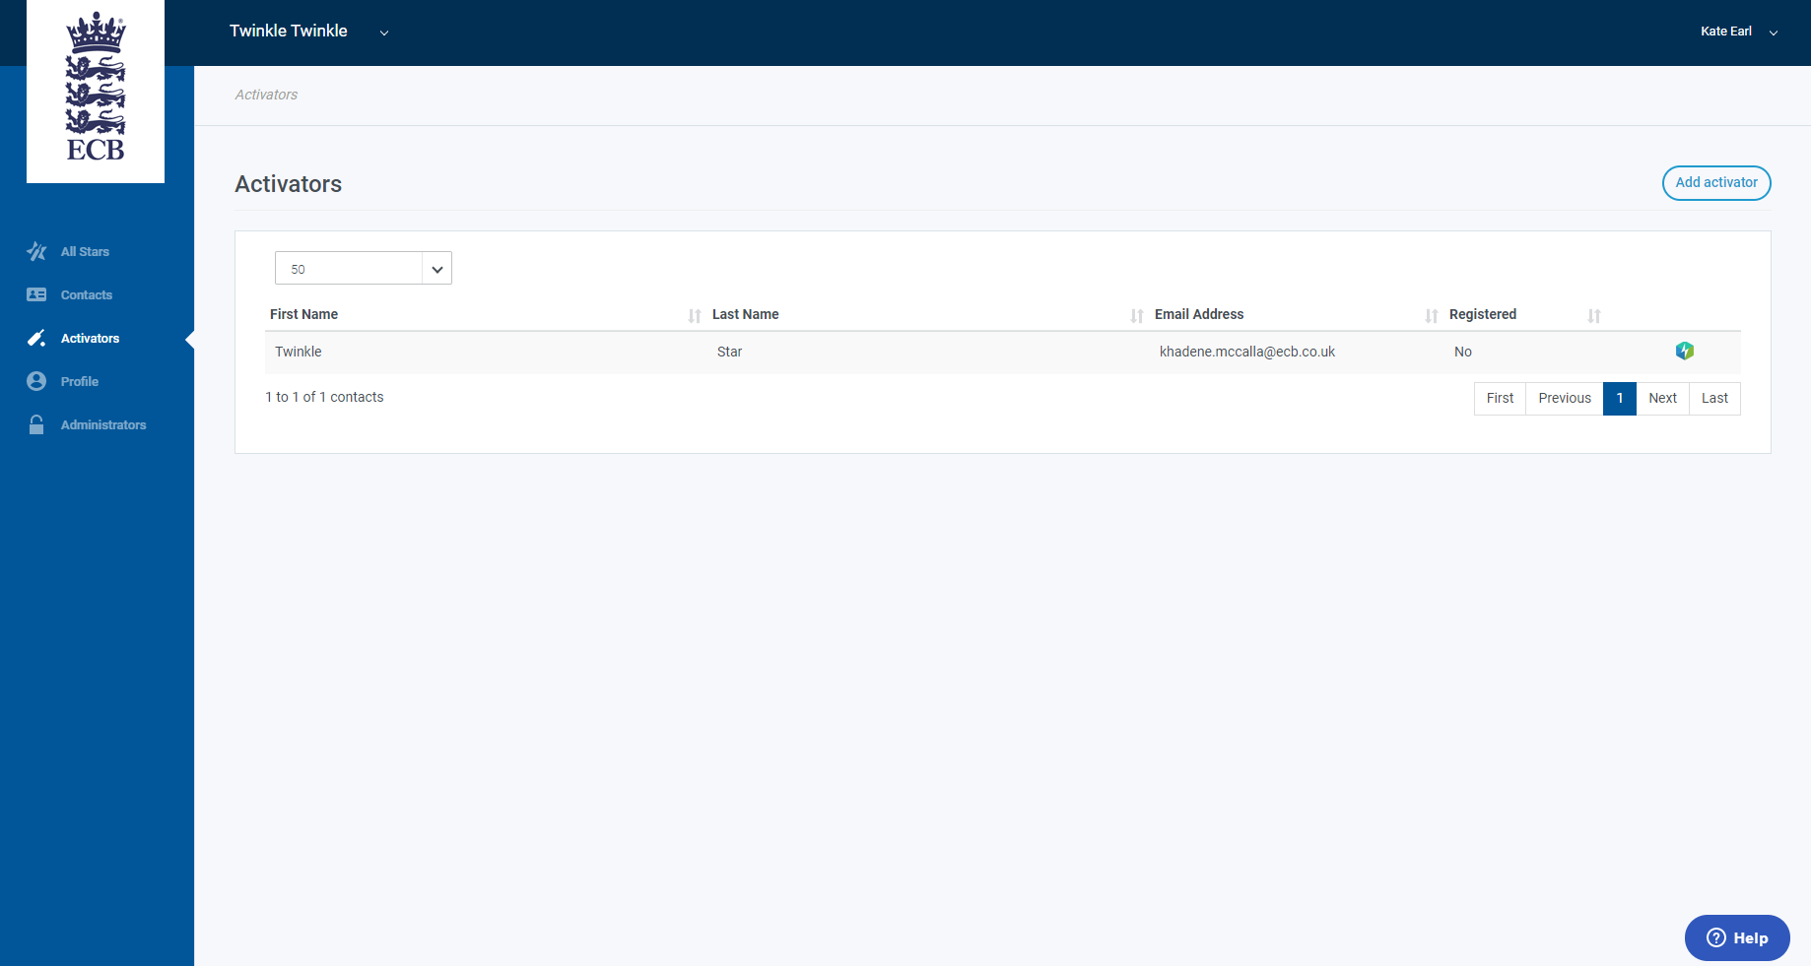

Click on the left-hand tab marked ‘Activators’ > click on the button in the top right corner marked ‘Add Activator’.

Please note that you have the choice to select an ‘Existing contact’ or add a ‘New contact’; if you select an ‘Existing contact’ you only need to enter their name and it will auto populate their details. Only choose a ‘New contact’ if the person has never registered the persons details on to your ClubSpark club profile as re-entering someone’s details will produce an error stating ‘details already in use.’ To see if someone’s details are already registered, check the ‘Contacts’ tab on the left.
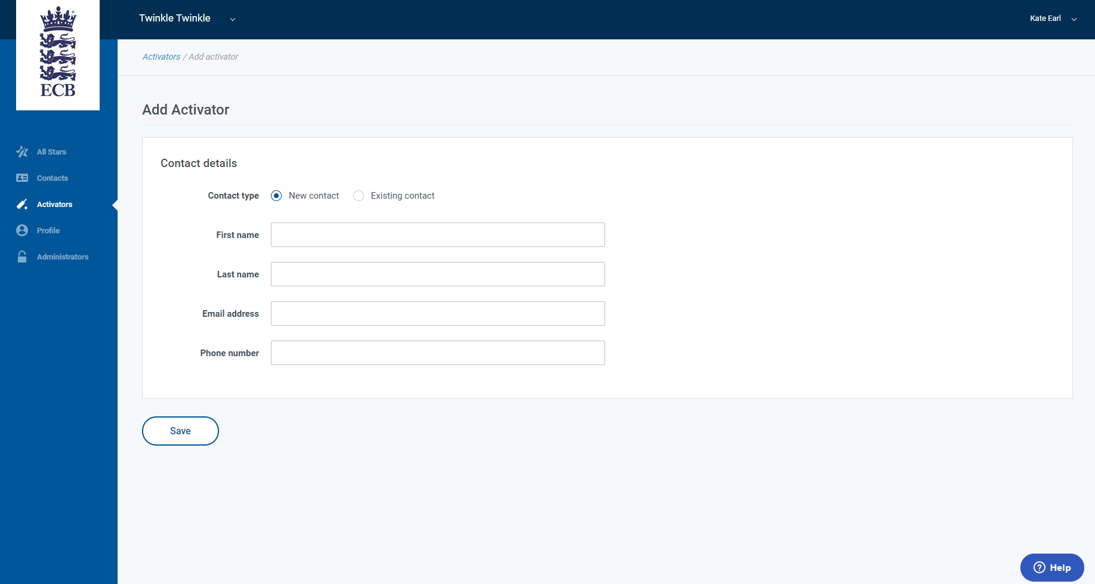

Input the Activators full name, email address and phone number and then click the button marked ‘save’ to update your profile. If you do not click ‘save’ then your profile will not get updated.

How do I add an Administrator?

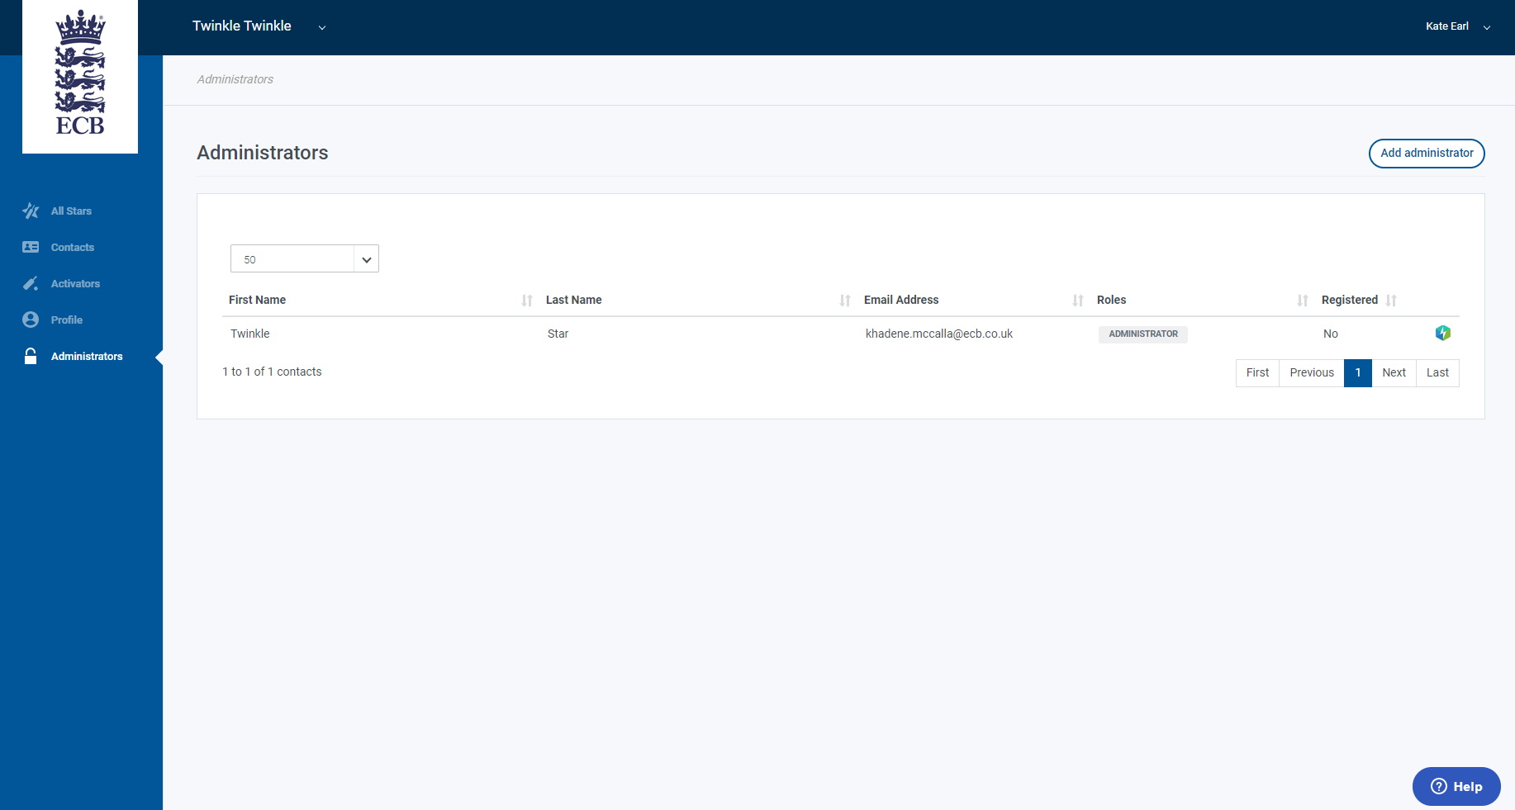

Click on the left-hand tab marked ‘Administrators’ > click on the button in the top right corner marked ‘Add Administrator’:

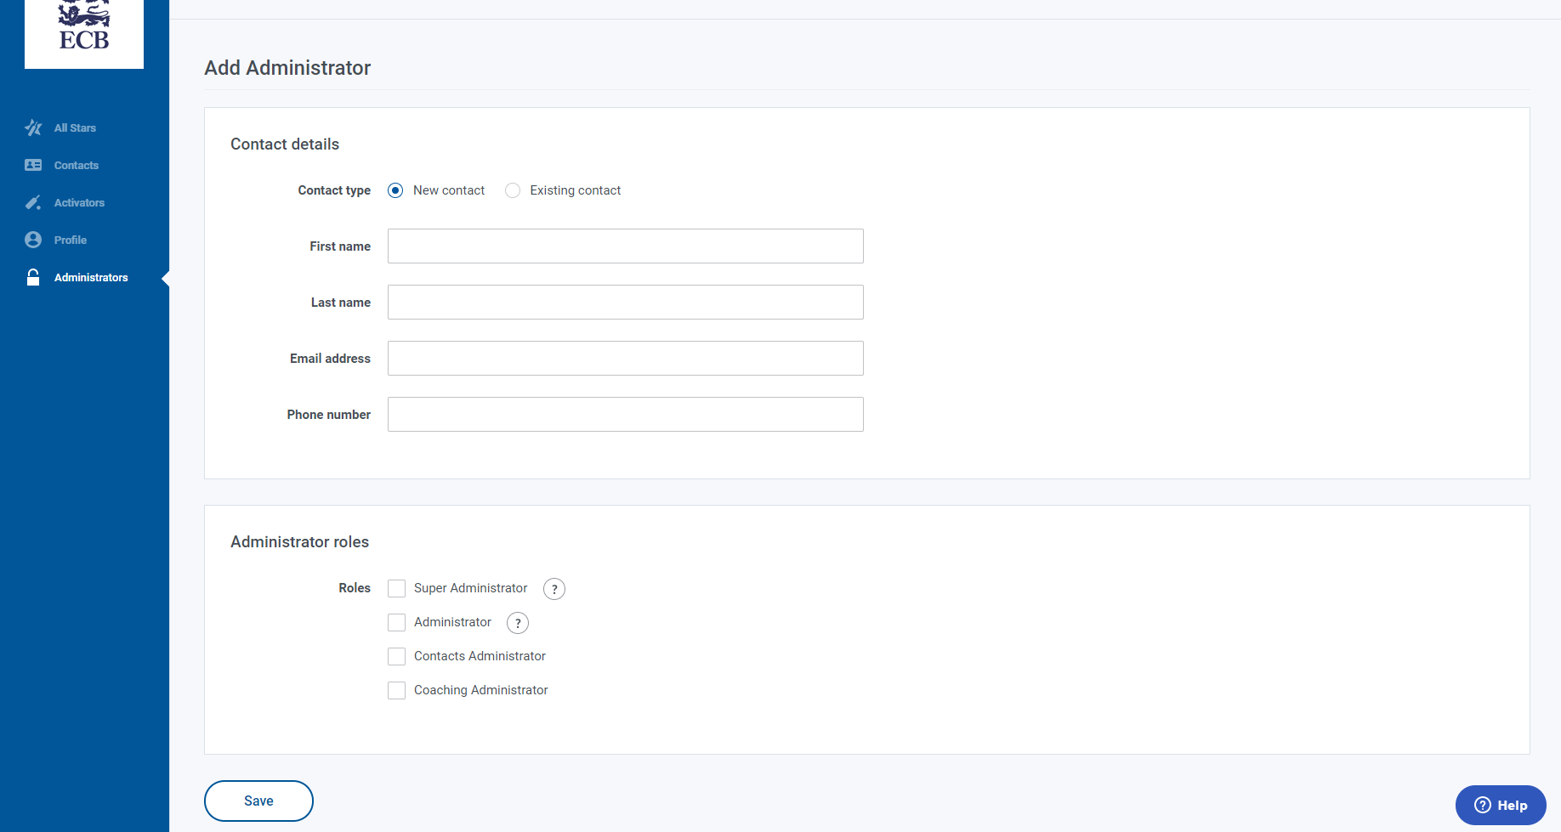

Input the Administrators full name, email address and phone number. You will then need to assign a role to the individual (please note that you can choose one or select multiple roles).

Click the button marked ‘save’ to update your profile. If you do not click ‘save’ then your profile will not get updated.

How do I know if a new Activator/Administrator has been registered?

Once you have added someone as an Activator/Administrator, an invitation will be sent to them (on the email address you provided when adding them), asking them to complete their registration.

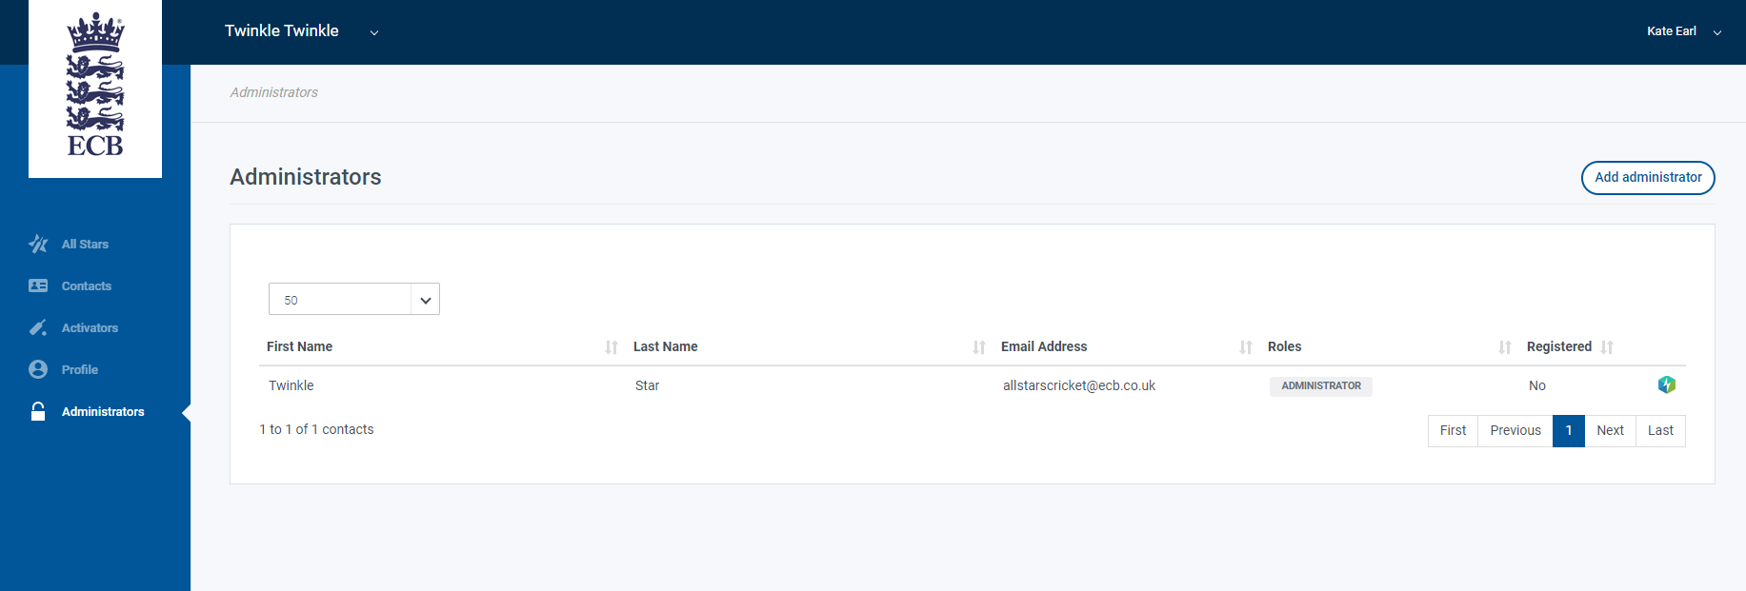

To see whether a person has registered, you can click on the Activator/Administrator tab, and you will see under the ‘registered’ tab, the status will either read:

- Invited: meaning an invitation has been sent and you can see the date it has been sent and when the invite will expire
- Yes: meaning they have accepted the invitation
- No: meaning an invitation has been sent but has expired. In this event please click on the individual’s name, wait for their profile to load and the select the button marked ‘invite contact’ to generate another invitation

How do I update my club’s electronic register?

Log in to ClubSpark > click the All Stars tab on the left > select the current programme > you will now have your programme and electronic register showing > please select the box next to the child’s name, against the relevant date, to mark their attendance:

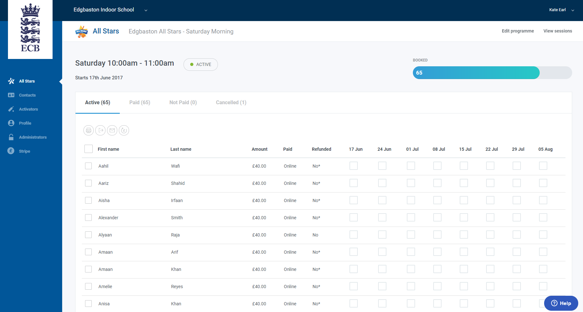

Please only update the electronic register after the session has taken place.

Remember to update the electronic register within 3 days of the session having taken place to ensure any electronic communications are generated. Communications may not be sent out if the electronic register is not marked in time.

Once you are on this screen, you have the option to utilise the 4 picture icons above the register to:

- Print out all participants’ information
- Export all participants’ information over to an Excel Spreadsheet (to save for your records)
- Email all registered parents
- Refund parents / children

Log in to ClubSpark > click the All Stars tab on the left > select the current programme > you will see
the electronic register with a list of all the participants > tick the box next to the title 'First Name' to highlight/select all the participants or you can click on the box next to the individual child’s name:
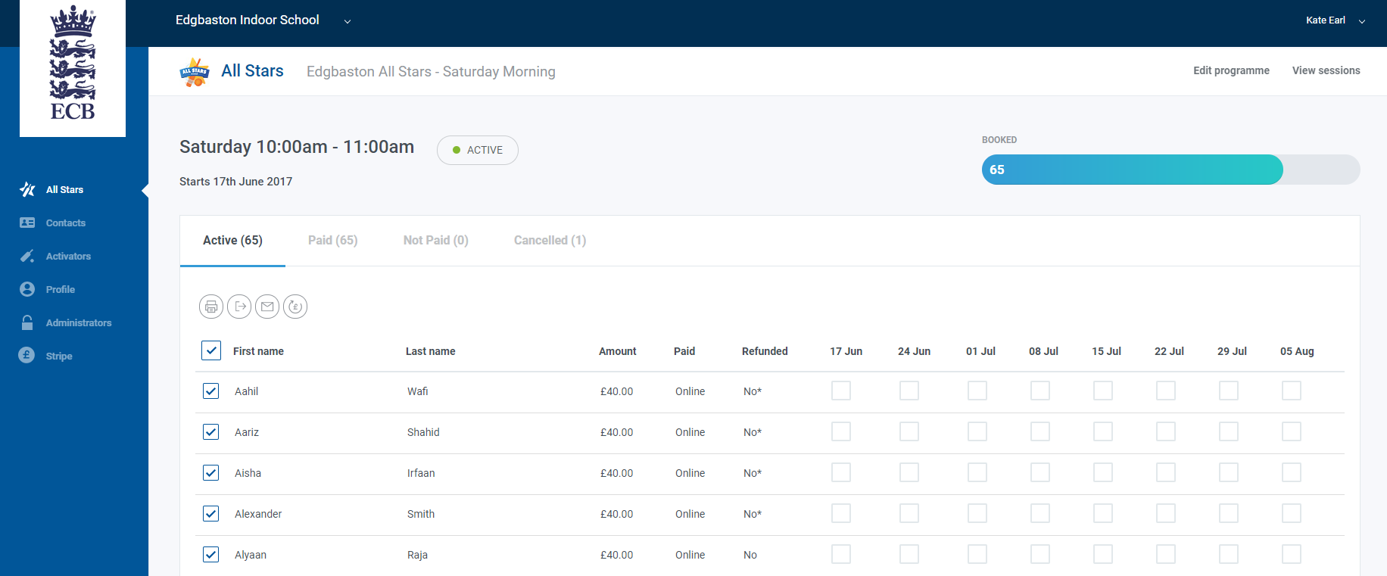

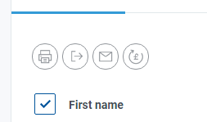

Once a child or all children on the register are highlighted, the 4 picture icons (above ‘First name’) will become available to use:

Select this icon to print off a list of all participants’ information

Select this icon to export all participants’ information to an Excel spreadsheet
(currently you cannot export parents volunteering status – to see this you will need to click on each child individually through the electronic register and selecting ‘Contact details’)

Select this icon to email all participants/parents

Select this icon to refund a participant(s)

What do I do now I’m registered on to ClubSpark?

Now that you have successfully set up your club’s ClubSpark account, you can update, keep on top of as well as amend the details for your All Stars programme.

If you are an Activator, please note that you will see the following screen upon next logging in to ClubSpark:
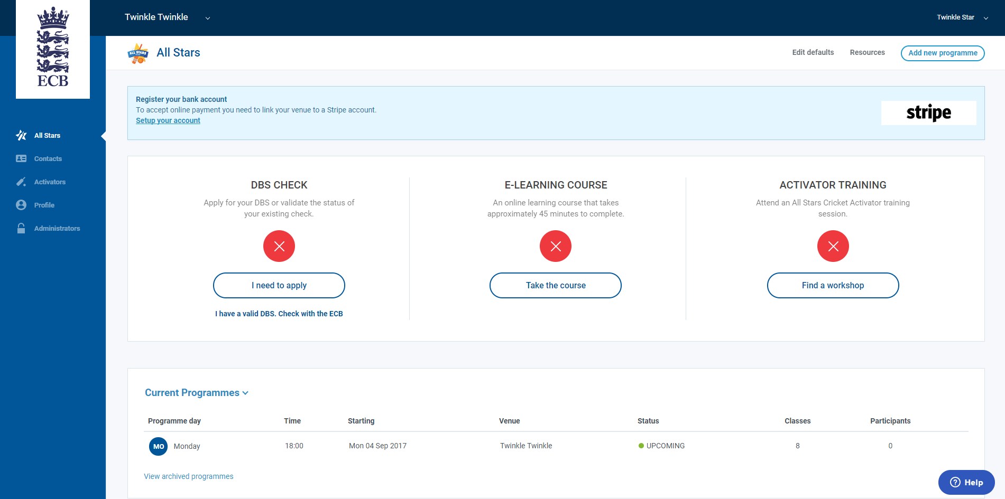

The 3 red crosses indicate what need to be completed, to be fully registered as an Activator:

- DBS Check (to ensure that you are legally able to coach the children)
- E-Learning Course (to be completed and please note this is different from iCoach)
- Activator Training (to be completed before programmes commence)

If you are an Administrator, please note that you will not see these red crosses; you will simply see the ‘Current Programmes’ running at your club.

Notes for ECB administration users

How to find a club?
Once you are logged in to ClubSpark, you will see the ‘Club Lookup’ tab, which allows you to search for a club either by their name or their address.

